**Request for Proposals**

Engineering Design Services for

Code Compliant Stairway Improvements at

12 Channel St, Boston Marine Industrial Park

EDIC Project No. 1272C

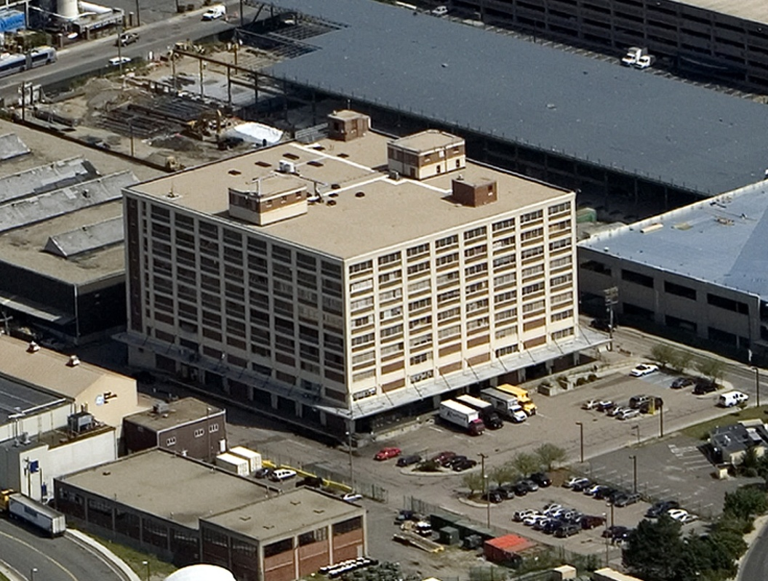

[www.lesvants.com](http://www.lesvants.com)

Thomas M. Menino, Mayor

**Peter Meade, Director**

**ECONOMIC DEVELOPMENT & INDUSTRIAL CORPORATION OF BOSTON**

One City Hall Plaza, Boston, MA 02201



Clarence J. Jones, Chairman Consuelo Gonzalez-Thornell, Treasurer

Brian P. Golden, Clerk Paul Foster, Member

Timothy P. Burke, Member James M. Coyle, Member

April, 2013

REQUEST FOR PROPOSALS FOR THE

**Engineering Design Services for**

**Code Compliant Stairway Improvements at 12 Channel St**

# **Boston Marine Industrial Park, Boston, MA**

AWARDING AUTHORITY:

Economic Development & Industrial Corporation of Boston

Engineering and Facilities Management Division

Capital Construction Department

22 Drydock Avenue, Suite 201

Boston, MA 02210

EDIC Project No. 1272C

April, 2013

## Thomas M. Menino, Mayor

Peter Meade, Director

# Request For Proposals

Engineering Design Services for

Code Compliant Stairway Improvements at 12 Channel St

# Boston Marine Industrial Park, Boston, MA

## Table of Contents

### Introduction

1. Objective
2. Site Location and History
3. Proposal Submission Requirements
4. Pre-proposal Meeting and Site Access
5. Proposal Selection Criteria
6. Contact Information
7. Performance of Services

#### Basic Services

### Kick-off Meeting

### Existing Conditions / Existing Materials Evaluation

### Code Summary Report and Recommendations

### Preliminary Design Drawings

### Final Design Drawings

### Bidding Assistance / Construction Administration / Final Testing

##### Supplementary Services

1. Reproduction Services
2. Resident Engineering
3. Hazardous Material Testing Allowance
4. Changes and Contingencies Allowance
5. Other Requirements
6. Time of Performance
7. Contract
8. Insurance Requirements
9. Miscellaneous

###### APPENDICES

### Existing Stairway Photos

* 1. Stairway Location Plan

Conceptual Design, Chain Link Installation, Gale Associates, Inc., 2001

### Designer Qualification Instructions & Statement

### Fee Schedule

### Sample Contract

# **Request for Proposals**

# **Engineering Design Services for the**

**Code Compliant Stairway Improvements at 12 Channel St**

# **Boston Marine Industrial Park**

1. **Introduction**

The Economic Development & Industrial Corporation of Boston (the “EDIC” or the “Authority”), is seeking proposals for the performance of engineering related services for the code compliant improvements to the east stairway at the 12 Channel Street Building in the Boston Marine Industrial Park in South Boston, MA.

1. **Objective**

The objective of this RFP is to hire an experienced and professional engineering firm (the Consultant) with the necessary subconsultants for providing design and construction-phase engineering services for code-compliant improvements to one (1) stairway in the EDIC-owned 12 Channel St building. The EDIC currently intends to perform upgrades to the east stairway in the building (see Appendix B for the stairway location). The scope of work includes the investigation of the existing conditions and materials, design services for code compliant improvements such as stairway pressurization, fire protection, and hand/guardrails, the development of construction documents for public bidding through M.G.L. Chapter 149, public bidding assistance, construction administration, resident engineering and final testing. The Consultant will have a professional engineer licensed in the state of Massachusetts as its lead designer and project manager. The Consultant will work with representatives of the EDIC and coordinate their work with the EDIC’s project manager on a continual basis.

1. **Site Location and History**

The site is located in the South Boston Waterfront section of Boston in the Marine Industrial Park and is identified by the EDIC as “12 Channel Street.” The area surrounding the site include an in-progress development site to the north, seafood processing companies to the west, a freight terminal to the east and a parking lot to the south.

The brick and concrete building, constructed in 1941 by the US Navy, consists of nine stories and a basement. The building footprint is 38,635 square feet with a gross building area of 357,361 square feet (35,414 square feet per floor). The maximum building height is 109 Feet. The building is a multi-tenant occupied building and has a use designation of F-1 Industrial Use and I-2 Manufacturing Zone. The existing fire alarm system was installed in circa 1978 with an upgrade performed in 2010.

In 2001, the EDIC contracted Gale Associates, Inc., to perform roof, masonry and stairwell repairs to the 12 Channel Street building. Due to budgetary restraints, the stairway repairs were eliminated from the scope of the project after being completed to a level of approximately 35%. Included within Appendix B is the 35% design submission for Gale’s recommendation to secure the stairway: the installation of chain-link fencing to seal off the stairwell opening. This design is included for informational purposes only.

1. **Proposal Submission Requirements**

Each respondent must deliver one original and five copies of its sealed proposals to the EDIC offices by no later than **12:00 PM, Wednesday, May 15, 2013.** A project approach letter from each respondent is required to be submitted identifying the scope of work as described in the RFP. The letter should include the name and resume of the Project Manager as well as all support staff and sub-consultants.

The Fee Schedule located in Appendix D should be filled out and included with the proposal. The respondent will estimate the project duration for the Stairway Improvements and include this estimate as part of a schedule submitted within the proposal.

Proposals should be delivered to EDIC Engineering & Facilities Management Division, 22 Drydock Avenue, Suite 201, Boston MA, 02210, attn: Mr. Lawrence D. Mammoli, Deputy Director for Engineering & Facilities Management.

1. **Pre-Proposal Meeting and Site Access**

#### A pre-proposal meeting shall take place at **10:00am on Wednesday, May 8, 2013** at the 12 Channel Street Lobby. The meeting will consist of a brief overview of the project, access to the East Stairway and a brief question and answer session.

#### The building is under the management of the EDIC Engineering & Facilities Management Division, MIP Operations Department. Authorization for site access must be coordinated with Mr. James Sorrentino, Deputy Director of Operation, at (617) 918-6203.

1. **Proposal Selection Criteria**

#### The EDIC will review all proposals submitted in accordance with this RFP. All proposals will be reviewed in accordance with and be subject to the criteria, procedures, submission requirements and other requirements outlined in this RFP. After receipt of proposals, the EDIC may, at its discretion, interview one or more respondents, during which time such respondent will have the opportunity to more fully present its proposal and respond to questions.

#### Upon submission, the responses to the RFP shall be evaluated by the EDIC project team on the following basis: relevant project experience (code review and building systems), quality of project team, responsiveness to the RFP, fee schedule and project schedule.

1. **Contact Information**

#### All questions regarding this RFP should be directed to the EDIC Project Manager, Mr. Nat Gorham, at (617) 918-6252 and by email at [nat.gorham.bra@cityofboston.gov](mailto:nat.gorham.bra@cityofboston.gov) or to Mr. Paul Osborn, Deputy Director of Capital Construction, at (617) 918-6211 and by email at [paul.osborn.bra@cityofboston.gov](mailto:paul.osborn.bra@cityofboston.gov).

1. **Performance of Services**
2. **BASIC SERVICES**

#### 

#### **Kick-off Meeting**

Within ten (10) days of issuing the Notice to Proceed, the Consultant will participate in a project

start-up conference with the EDIC. The purpose of this meeting will be to introduce all members of the project team, review project communications, finalize scope, review schedule, review permitting strategy, and to discuss in detail our design milestones and deliverables. This meeting will be also used to make initial refinements to the design program as provided in the concept planning performed to date.

#### **Building / Existing Materials Investigation**

Building Investigation

The Consultant shall perform all necessary site visits to evaluate and investigate the east stairway (see attached plan for location). Building elements under review include, but are not limited to: guards and handrails; signage (emergency, exit and floor numbers), lighting (emergency, illumination and power sources); means of egress doors (construction, swing direction, widths, hardware, closing mechanisms); Fire suppression system (smoke detectors, fire alarms and sprinklers, piping and conduit, stand pipe connection, overall functionality); stairwell pressurization (fans, dampers, power, sensors, controls, openings); overall physical condition of the stairway enclosure (windows, concrete, roof, masonry walls, water and air infiltration, paint); stair treads and slip-resistance; any and all other elements required by the building code for exit stairways and means of egress.

During the investigation, should the Consultant suspect the potential for hazardous material, the Consultant shall provide the Authority with a proposal for quantifying, testing, and incorporating said hazardous materials into the contract documents and estimate for abatement by the Contractor. A preliminary copy of the Hazardous Materials Investigation report shall be provided to the EDIC for review and comment. Cost for these services shall be drawn from an allowance listed under Task 3 in the Supplementary Services as Hazardous Material Testing Allowance.

Existing Materials

The Consultant shall be responsible for the evaluation of existing materials including, but not limited to, the following drawings in the possession of the EDIC. Large-format versions of the following drawings are available for review as a hard copy at the EDIC Capital Construction Department located at 22 Drydock Ave, Suite 201, or as a digital PDF file by contacting Nat Gorham at (617) 918-6252 or by email at nat.gorham.bra@cityofboston.gov.

1. Building 32 (12 Channel St.), Original plans, U.S. Navy, 1944.
2. Renovations to 12 Channel St., (Electrical, sprinklers, emergency services), various.
3. 12 Channel St. Tenant Construction Guidelines, EDIC Engineering & Construction Dept., October 1991.
4. 12 Channel St. Building Analysis and Master Plan, Chia-Ming Sze Architects, Inc., March 1991.
5. Stairway Elevation and Floor Plan. Building 32, BMIP, Gale Associates, Inc., April, 2001.
6. Fire Alarm System Improvements, 12 Channel Street, BLW Engineers, Inc., July, 2010.

#### **Code Summary Report with Recommendations and Estimates**

At the conclusion of the Task 2, the Consultant shall prepare and present to the Authority a *Code Summary Report* which includes the results of the building investigation, a table of the code deficiencies and an itemized estimate for the repairs necessary to bring the project area to code.

The report to the Authority shall include three (3) separate recommendations for bringing the stairway guard, well opening and handrail system up to code, along with code issues associated with each option. The Consultant will have an open discussion with the EDIC on which design best benefits the Authority and whether portions of the construction work may be completed in phases and the costs associated with these options. Based on the information presented, the Authority may choose a design option and the Consultant shall pursue this design into Preliminary Design Drawings. The Authority reserves the right to request additional recommendations at no additional cost to the Authority should the Consultant fail to present a viable design solution at this meeting. A presentation of this material to the EDIC shall take place within **45 working days** from the date of the kick-off meeting.

#### **Task 4 - Development of Preliminary Contract Documents and Engineer’s Estimate**

Upon approval of Task 3, the Consultant will prepare preliminary design drawings in accordance with all federal, state and local regulations including but not limited to the Massachusetts State Building Code, The City of Boston Fire Department Regulations, NFPA, Americans with Disabilities Act and the City of Boston Inspectional Services Department. The Consultant will be expected to work in conjunction with the various other professionals contracted by the EDIC and to perform the services in connection with the project (including, without limitation, appraisers, attorneys, the Tenants, and any other Government or City agencies) involved with the project.

The Consultant shall provide details of the recommendations for physical improvements to the stairway including, but not limited to: alteration or installation of improvements to the handrails and guards, stairway pressurization, fire alarm and fire rated systems, the egress doors, exit signage and emergency power, physical and aesthetic improvements, and any other recommendations which are required or recommended as a result of the building investigation. The Consultant shall submit contract documents, an updated engineer’s estimate and the specification sections necessary for performing the work. The preliminary design drawings and general specifications should be at a sufficient level of detail to clearly show all requirements of the project and be considered 80% complete.

The Consultant shall design the documents with the understanding that the building shall remain occupied and accessible during construction. Plans showing the existing “as-built” conditions are on-file and available from the Authority for your reference. AutoCAD drawings are available for each of the floor plans. The Consultant will be required at the end of the project to submit updated as-built drawings to the Authority for its records. To arrange to review or obtain copies of existing plans, contact Mr. Nat Gorham, (617) 918-6252.

#### **Task 5 - Development of Final Design Documents for Public Bid**

On the basis of the approved preliminary designs, the Consultant shall prepare and submit to the Authority the Final Contract Documents for construction drawings and detailed specifications and an updated Engineers Estimate. These shall be in a form suitable for public bidding (Chap. 149 M.G.L). The drawings and specifications shall be submitted to the EDIC both in electronic format (AutoCad and PDF) and a set of mylar reproducibles.

Without limitation, the Final Design Documents may include specifications for:

Electrical HVAC

System Manuals Stairwell Pressurization

Fire Safety / Protection Handrails and Guards

Painting/Patching Submittals

Permitting Shop Drawing Submittals and Approval Procedures

Construction Schedule Safety Procedures

Working Hours Noise Level Restrictions/Dust Control

Completion Dates Windows

Finishes Phasing

Project Close Out As-Built Contract Drawings

Doors Code Compliance

Windows Performance Verification and Testing

Hazardous Material Abatement Ductwork

Conduit Emergency Power

**Task 6 – Public Bidding Assistance, Construction Administration and Final Testing**

The Consultant shall participate in pre-bid Conference, prepare addenda, assist the Official in the tabulation of bids, report on the qualifications of three lowest bidders and make a recommendation for the award of the contract. The Consultant shall prepare supplemental details as needed, review and approve materials and shop drawings, samples and other submissions of the Contractor for conformance with the working drawings and detailed specifications.

The Consultant shall visit the site as the progress of construction requires but not less than twice weekly, prepare design details and estimates for all proposed changes in the work and review the Contractor’s proposals and estimates for performing changes in the work. The Consultant shall submit weekly reports to the Official as to the progress of the construction and performance of the work, review the Contractor’s periodic estimates for payment, supervise all final testing of systems and permitting/acceptance by the Boston Fire Department and other governing bodies, recommend and certify substantial completion date, prepare “punch lists” for project close-out. The Consultant shall estimate the services for construction administration based on a construction duration of 16 weeks.

The Consultant shall provide “As-built” drawings and specifications electronically and as a set of reproducible mylars with “As-Built” clearly noted at the lower right hand corner of each sheet. Electronic files shall be in two formats, the Consultant shall provide the EDIC with updated recent versions of AutoCAD (.dwg) and Adobe (.pdf) file formats.

#### **SUPPLEMENTARY SERVICES**

#### **Reproduction Services**

EDIC shall provide the Consultant an Allowance for reproduction services. Upon written request of EDIC, the Consultant shall submit a detailed cost estimate for the reproduction and delivery of that quantity of suitably bound reproductions of the contract documents prepared for public bidding. Upon EDIC approval, the Consultant shall arrange with an approved vender for reproduction services. The EDIC shall pay the Consultant at the rate of One Hundred Ten Percent (110%) of the actual cost incurred by the Consultant up to the contract limit specified. These costs shall be drawn from the price set in Task 1 of the Supplementary Services located within the Fee Schedule.

#### **Resident Engineering**

It is anticipated that 16 weeks of Resident Engineering Services will be required for the Stairway Improvements. The cost for these services, tabulated under Task 2 of the Supplementary Services, shall be calculated as such: **8hrs x 5 days x 16 weeks x the hourly rate**. Please provide the Authority with the resume and hourly rate for the Consultant’s Resident Engineer for evaluation within the response to the RFP. The EDIC shall allocate the Resident Engineer on as-needed basis per the EDIC Project Manager.

#### **Hazardous Material Testing Allowance**

In the course of the building investigation, should the Consultant uncover the potential of hazardous materials in the building (asbestos-containing tile or pipe insulation, mercury containing ballasts, lead-based paint, etc.) which may be affected by the improvements under this project, the Consultant shall submit to the authority a proposal for testing and documenting said materials. The Consultant shall determine the locations and quantities of any Hazardous Material and implement the removal of said materials into the Contract Documents. The cost for testing, reporting to the Authority and designing its abatement into the project shall be drawn from this allowance upon approval.

#### **Changes & Contingencies Allowance**

#### Changes and Contingencies shall be used at the discretion of the Authority when unforeseen conditions arise and engineering services are requested that are not included in the original engineering contract.

1. **OTHER REQUIREMENTS**
2. **Time of Performance**

The Consultant shall include in the proposal letter to the Authority the estimated time for completing Task 1-6. It is expected that within 30 days from receiving proposals the EDIC will issue a Notice to Proceed.

**2. Contract**

#### By submitting a proposal in response to this RFP, each respondent agrees that if the EDIC selects such respondent to perform the Services, such respondent shall, immediately upon such selection, execute a contract in substantially the form of the contract attached hereto as Appendix F. Any unacceptable terms should be identified as part of the RFP submission.

**3. Insurance Requirements**

#### The selected Consultant will be required to maintain at least Two Million Dollars ($2,000,000) in project specific pollution liability insurance coverage from a reputable insurance company. In addition, the selected Consultant (i) shall maintain at least Two Million Dollars ($2,000,000) in Professional Liability Insurance and (ii) will be subject to the standard insurance requirements of the EDIC.

**4. Miscellaneous**

#### It is expected that the Consultant team members, submitted as part of the RFP submission, shall remain on the project team for the duration of the project. No substitutions of team members shall be permitted without the express written authorization of the EDIC.

The EDIC reserves the right to postpone or withdraw this RFP; to accept or reject any and all proposals; to modify or amend the terms of this RFP or to waive any requirement of this RFP with respect to one or more respondents; to negotiate or hold discussions regarding the terms of any proposal received in response to this RFP or take any other actions with respect to issuance or award of this RFP; all as the EDIC may deem to be in the best interest of the EDIC and/or the City of Boston. The EDIC also reserves the right to interrupt any portion of the Consultant’s contract once fully executed. EDIC may decide not to proceed further at the completion of each task of the Basic Services.

**APPENDIX A**

**Existing Stairway Photos**

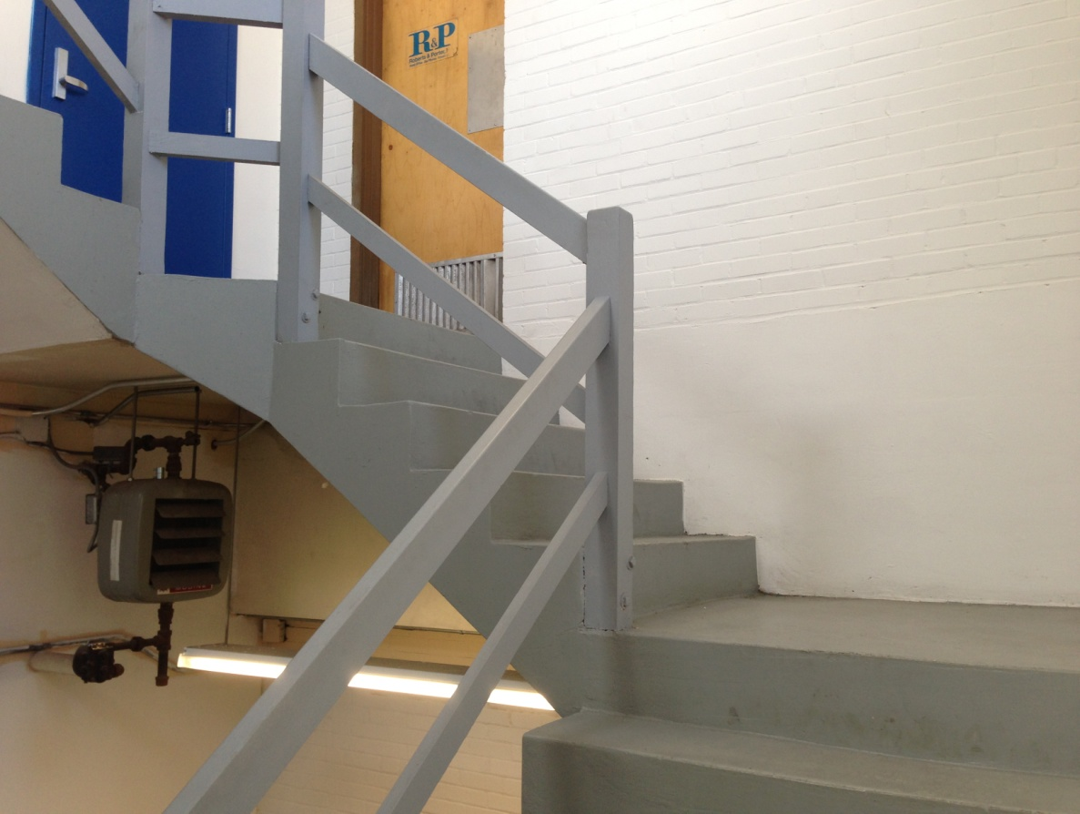

**Existing railings at 12 Channel Street**

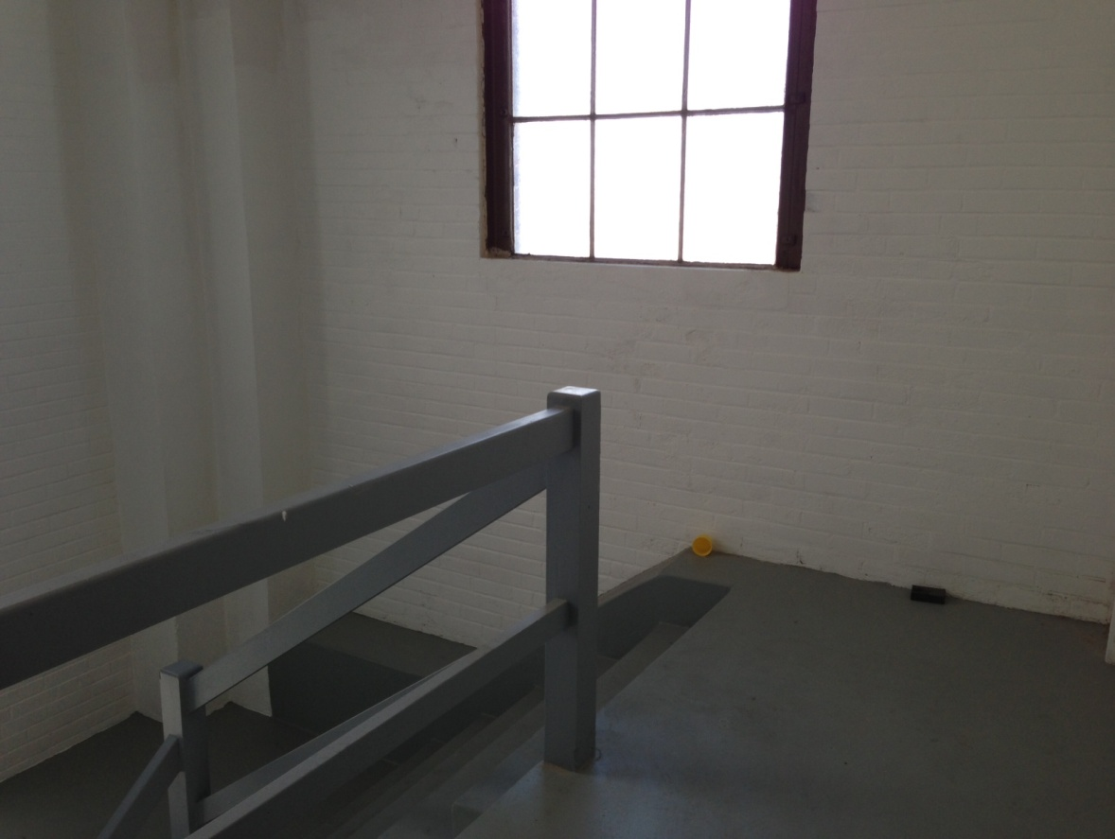

**Existing railings at top floor of 12 Channel Street**

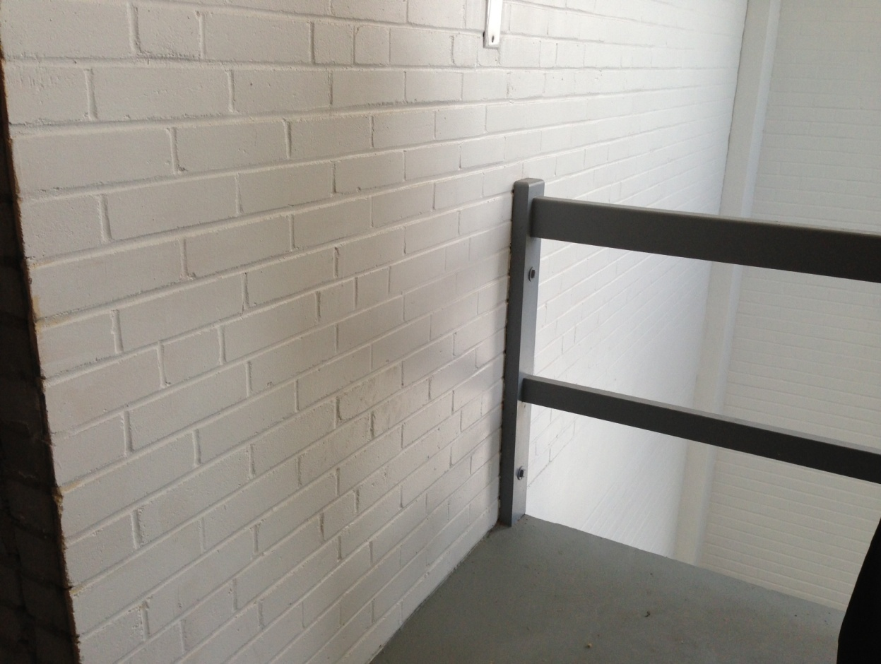

**Railing connection to wall at top floor of 12 Channel Street**

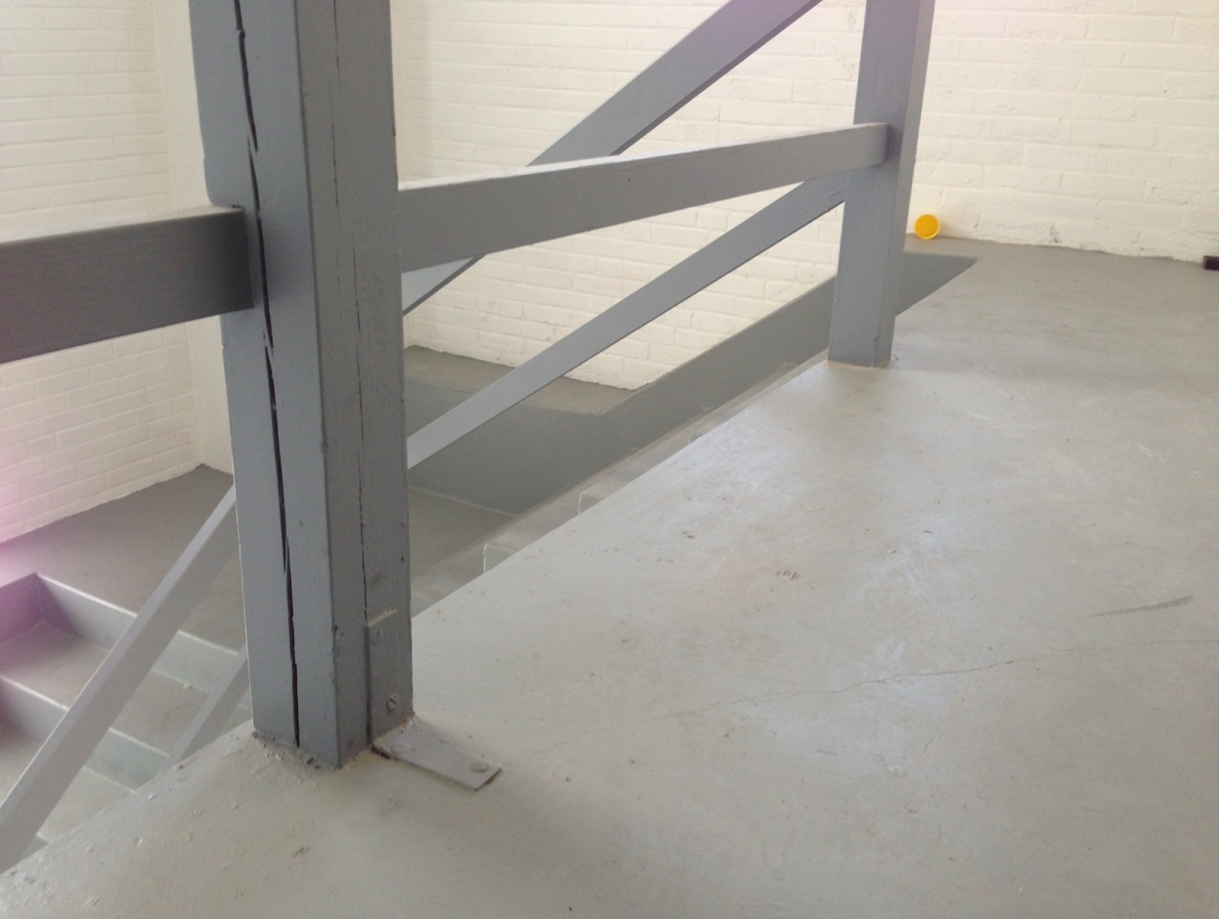

**Railing connection to floor at top floor of 12 Channel Street**

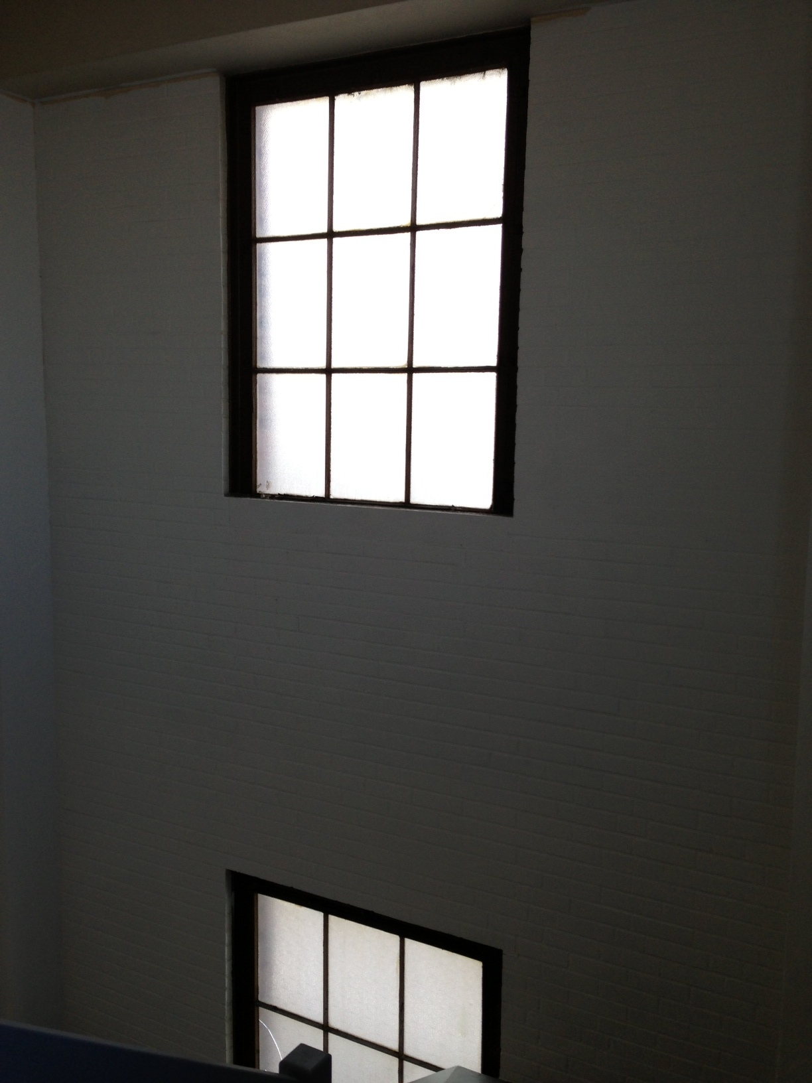

**Typical window in stairway at 12 Channel Street**

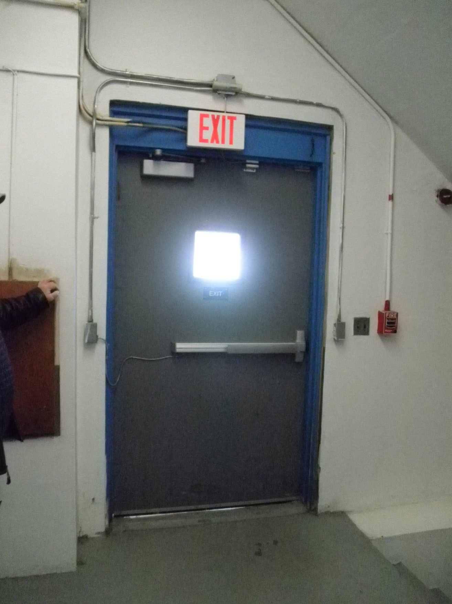**Emergency exit door, exit to outside from first floor of 12 Channel Street**

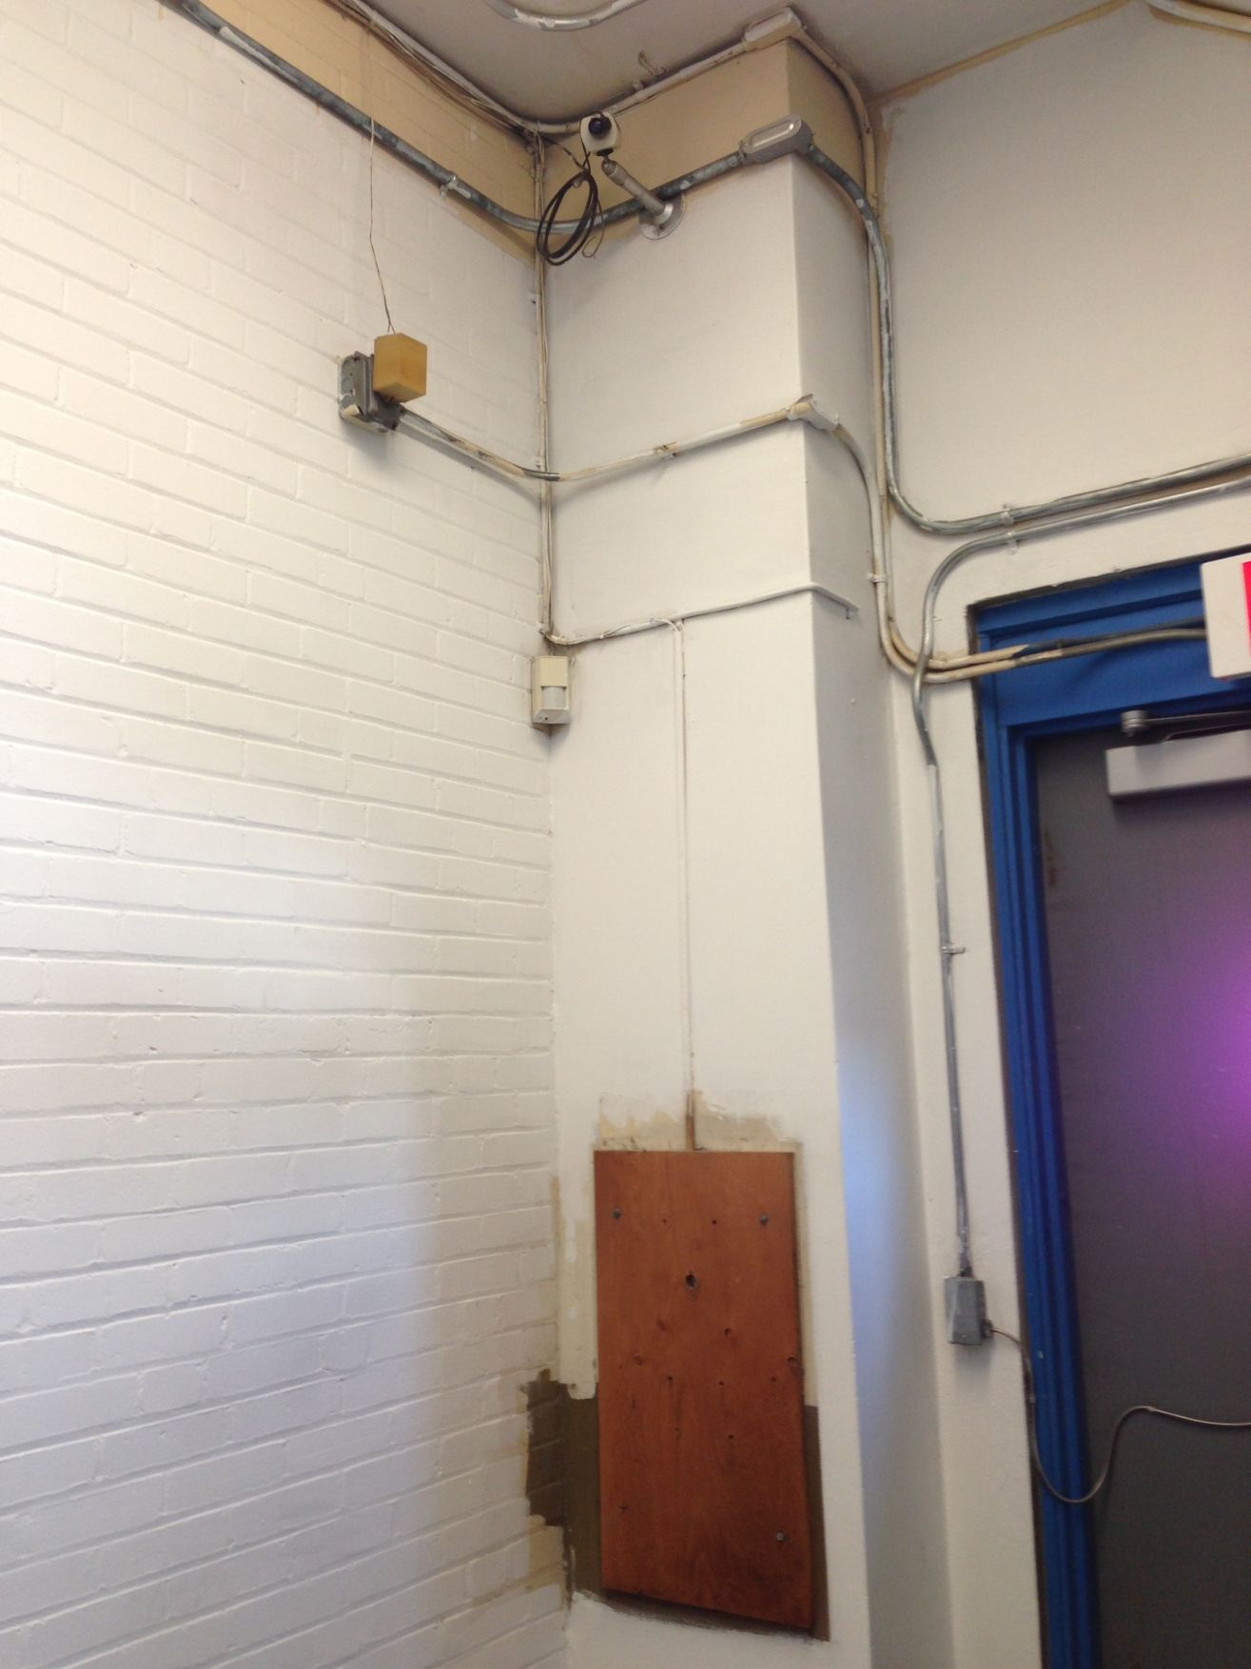

**Equipment at emergency exit on first floor of 12 Channel Street**

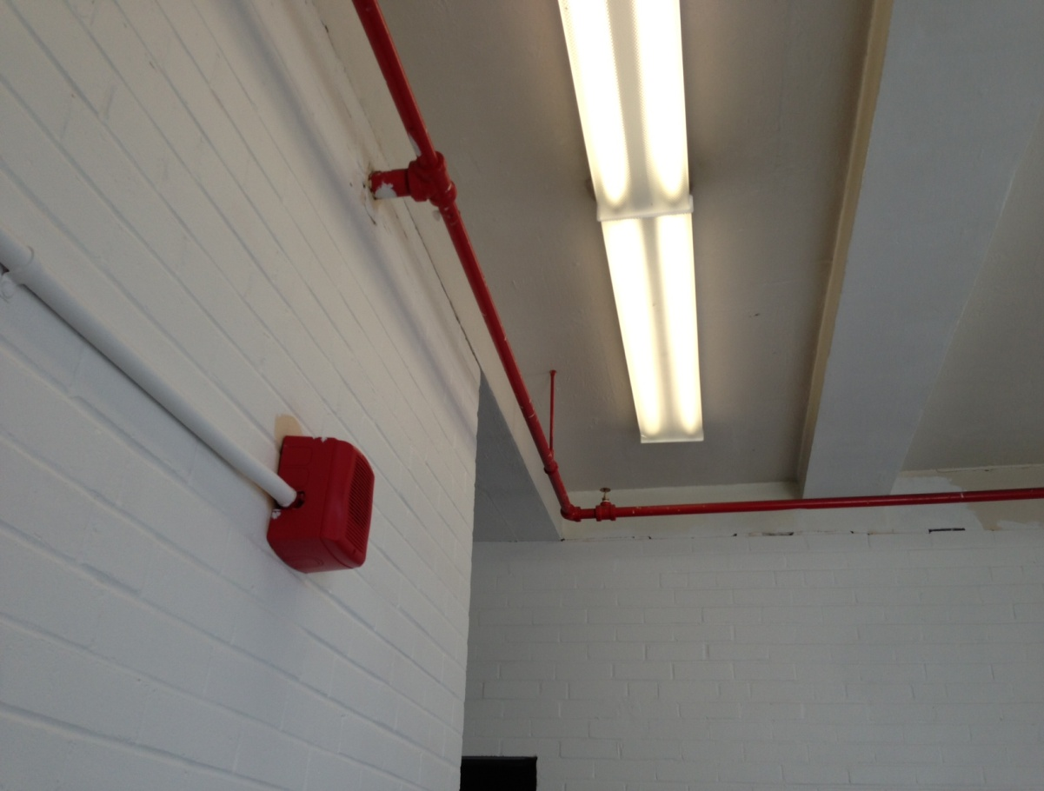

**Fire Safety equipment at 12 Channel St**

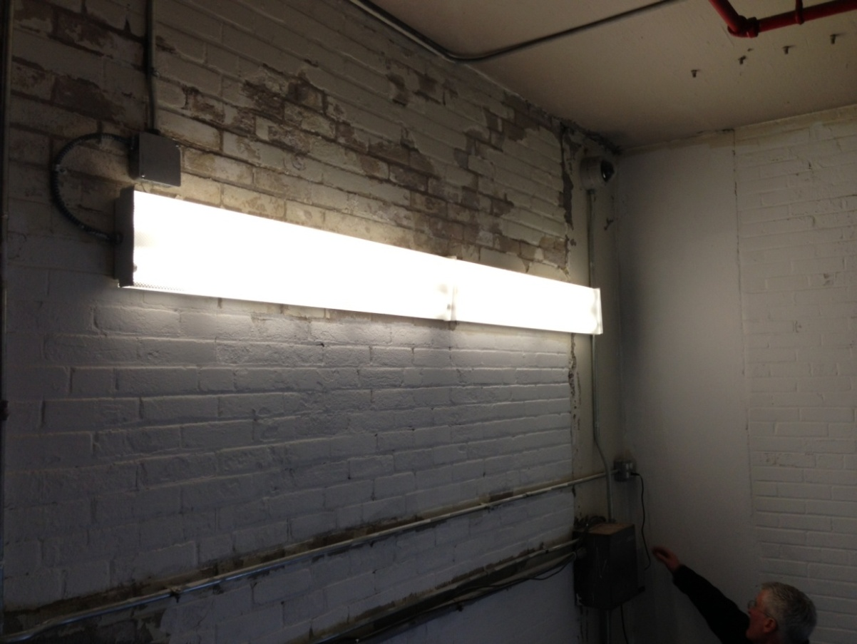

**Lighting in stairway at 12 Channel Street**

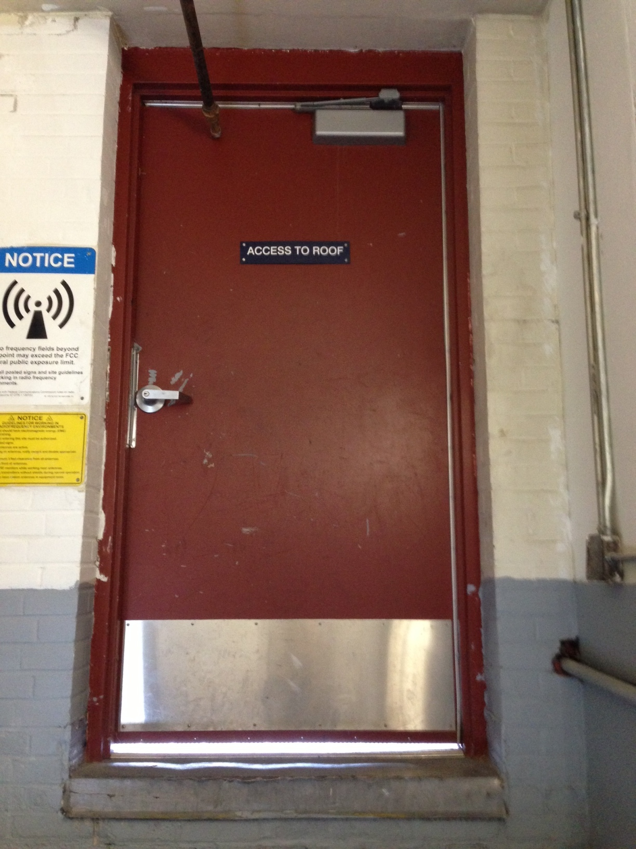

**Door providing access to roof at 12 Channel Street**

**APPENDIX B**

**Stairway Location Plan**

**Conceptual Design, Chain Link Installation,**

**Gale Associates, Inc., April, 2001**

**APPENDIX C**

**Designer Qualification Instructions**

**&**

**Designer Qualification Statement**

**Economic Development & Industrial Corporation**

**Thomas M. Menino, Mayor**

Clarence J. Jones, Chairman

Peter Meade, Director

Brian P. Golden, Clerk



**INSTRUCTIONS TO ALL APPLICANTS**

ARCHITECTURAL / ENGINEERING SERVICES

REQUEST FOR PROPOSALS

***Designer Qualification Statements*** (DQS) are to be submitted and completed in full. Failure to provide the information requested in the EDIC Designer Qualification Statement will result in lower numerical ratings by the Designer Selection Board. Answer all questions as stated in the DQS. Attach a cover letter with the DQS. The respondent may elect to add additional written text to describe project approach and understanding and what other additional information the respondent deems necessary to describe its qualifications. If a project schedule is not indicated in the RFP, provide the same. This information should be located in front of the DQS in your proposal.

1. ***Designer Selection Process***

Each project application or RFP for Architectural / Engineering services is reviewed and numerically rated by a qualified Designer Selection Board. From this rating, depending on the quality and range of submissions, the EDIC may narrow down the field to 3-4 firms and interview these firms individually in a presentation format. In such a scenario, a Designer Selection Board of EDIC, made up of typically 3-7 members (depending on the type and size of the project), will meet with finalists to make a decision. If presentations are unnecessary and the EDIC can make a decision based on the proposals themselves, a recommendation of a selected firm is sent to the EDIC Board for final approval to start contract negotiations.

A contract will be awarded based on the selection of the most favorable proposal of services. Each proposal will be initially evaluated to determine whether the respondent submitting the proposal meets the minimum threshold requirements described in subsection A below. Those respondents and the proposals of those respondents, which the EDIC has determined have met the minimum threshold requirements, will then be evaluated according to the evaluation criteria described in subsections B and C below.

**A. Minimum Threshold Requirements**

Each respondent submitting a proposal must meet the following minimum threshold requirements:

1. As of the date of the proposal submission, the respondent must have been licensed/registered as a “Licensed Professional Engineers and/or Architect” for at least one-year continuously under the same name.

2. The respondent must not be experiencing any financial problems that might render it unable to complete performance of the work.

3. The respondent must demonstrate that it has adequate insurance and an appropriate risk management strategy.

4. The EDIC shall have determined that the respondent is in compliance with all applicable statues governing conflict of interest.

5. The respondent must have an office, staffed by the primary project personnel, within a reasonable commuting distance (approximately one hour by car) from the Project Area.

**B. Qualifications and Experience**

All respondents determined to have met the minimum threshold requirements will then be evaluated based on the following criteria:

1. Respondent’s experience, qualification and level of commitment.

2. Experience and qualifications of the person to be assigned as project manager for the work.

3. Experience and qualifications of other key personnel of the respondent and the other individuals and any proposed team members who will be performing work.

4. Respondent’s experience in performing services of the same type as the Services.

**C. Technical Qualifications**

All proposals of all respondents determined to have met the minimum threshold requirements will then be evaluated based on the following additional criteria:

1. Respondent’s understanding of the scope of work as demonstrated by the respondent’s approach in responding to this RFP and towards performing the work.

2. Quality of the written proposals and any oral presentations.

3. Ability to complete the Services on time and within budget.

4. Respondent’s proposed work plan and staffing.

5. Respondent’s achievements in affirmative action hiring.

The respondent’s proposed consulting fee will also be considered in the review of proposals, however, this RFP will not be awarded based on price.

Selection of the Consultant is subject to approval by the EDIC Board of Directors.

**2.). *Proposal Format***

**A.) Technical Proposal**

All technical proposals should contain the following information:

**1. A Completed Designer Qualification Statement with a Letter of Introduction and other supporting documentation as requested below.**

**2. Experience of the Respondent**

(a) Describe generally any relevant experience that the respondent and its principals have had in connection with the provision of services similar to the services being requested by this RFP and any other relevant activities. Include the substantive nature of comparable contracts and the experience of members of the team in working on similar projects.

(b) Describe specifically any recent project(s) that the respondent has completed that would evidence its ability to achieve the objective of this RFP.

**3. Approach**

Provide a statement of the respondent’s approach to the performance of the Services. This statement should clearly demonstrate the respondent’s understanding of the requirements of this RFP and the scope of services. This statement should identify the number of public meetings, meetings with the EDIC staff, and meetings with other governmental agencies that the respondent believes will be required to complete the services.

**4. Schedule**

Provide a schedule of performance, outlining each activity required to be performed within each task described in this RFP, and providing a timeline for the completion of each such activity. Respondent must also include a list of applicable permits and outline each activity in its overall schedule.

**5. Additional Information**

(a) A completed Non-collusion and Tax Compliance Form, attached hereto as Appendix G and Appendix H, respectively. These appendixes are located in the Designer Qualification Statement, which is located in Appendix E of the RFP.

(b) Any other information about the respondent’s experience or qualifications to perform the services that have not been presented in previous responses and that the respondent believes is relevant to this RFP.

Rev. 01/09/12



**Economic Development & Industrial Corporation**

**Thomas M. Menino, Mayor**

Clarence J. Jones, Chairman

Peter Meade, Director

Brian P. Golden, Clerk

**DESIGNER QUALIFICATION STATEMENT**

SUBMITTED TO:

**Lawrence D. Mammoli, Deputy Director for Engineering and Facilities Management**

**Economic Development & Industrial Corporation**

**22 Drydock Avenue, Suite 201**

**Boston, MA 02210**

SUBMITTED BY:

|  |  |
| --- | --- |
| NAME |  |
| FIRM |  |
|  |  |
| ADDRESS |  |
|  |  |
| TELEPHONE / FAX |  |

*All questions must be answered by the designer in order for this qualification form to be properly submitted to the Economic Development & Industrial Corporation (EDIC). The designer must demonstrate that he has the financial and human resources immediately available to complete a given project on time and in a professional manner. The EDIC will regard this statement as an accurate portrayal of the designer's qualifications and any discrepancy between these statements and any other investigation may result in the proposal being rejected. If additional space is needed, attach 8 1/2 " x 11" sheets.*

|  |  |
| --- | --- |
| Project Name | Engineering Services for Code Compliant Stairway Improvements at  12 Channel St, Boston Marine Industrial Park |

|  |
| --- |
| ***EDIC - Designer Qualification Statement*** |

***Company Information:***

|  |  |
| --- | --- |
| 1. Name of Organization: |  |
| 2. Address: |  |
| 3. Telephone: |  |
| 4. FAX Number: |  |
| 5. President's Name: |  |
| 6. Vice-president's Name: |  |
| 7. Secretary's Name: |  |
| 8. Treasurer's Name: |  |

9. How many years has your firm been in business under this name?

____________________years

10. Is your firm a Commonwealth of Massachusetts Corporation?

YES__________ NO__________

11. Total number of employees in the firm?

_____________________(Number)

12. What is your professional staff longevity? *Formula : (Total years of professional staff employed at your firm divided by the number of professional staff)*

____________________(Number)

13. What is your professional staff experience? *Formula : (Total years of professional service divided by the number of professionals)*

____________________(Number)

14. Does your firm have a published affirmative action policy?

Yes_____ No_____

15. Are your principle offices located in the **City of Boston** (Suffolk County)?

Yes_____ No_____

16. If your answer is "NO" to number 15 does your firm have a "satellite" office in the **City of Boston** (Suffolk County)?

Yes_____ No_____

17. Is your firm listed as a "Minority Business Enterprise" or Women Business Enterprise with the **City of Boston**?

Yes_____ No_____

18. Does your firm currently have Professional Liability Insurance?

Yes_____ No_____

19. If you answered yes to Question 18., what is the maximum limit of the Insurance policy?

$____________________

20. Does your firm find acceptable the terms and conditions of an EDIC Engineering Contract (sample enclosed)

Yes_____ No_____

21. List all technical disciplines in which **your firm** is qualified to design:

Architectural Yes_____ No_____

Civil/Structural Yes_____ No_____

Code Review Yes_____ No_____

Fire Alarm/Safety Systems Yes_____ No_____

Mechanical (e.g., HVAC) Yes_____ No_____

Plumbing (e.g., sprinkler) Yes_____ No_____

Electrical Yes_____ No_____

Resident Engineering Yes_____ No_____

Permitting Yes_____ No_____

Environmental Yes_____ No_____

Estimating Yes_____ No_____

Permitting Yes_____ No_____

Testing/Commissioning Yes_____ No_____

Other specialty design

List:

22. Name any sub-consultant and the technical disciplines in which the sub-consultant is qualified to design for this project:

|  |  |
| --- | --- |
| Architectural |  |
| Civil/ Structural |  |
| Code Review |  |
| Fire Alarm/Safety Systems |  |
| Mechanical |  |
| Plumbing |  |
| Electrical |  |
| Resident Engineering |  |
| Permitting |  |
| Environmental |  |
| Estimating |  |
| Permitting |  |
| Testing/Commissioning |  |
|  |  |
|  |  |

Other specialty design (List):

**Company Experience:**

23. What is your firm's accumulated total gross sales (design fees for all projects) for the past three (3) years?

$____________________

24. What is the total number of individual design projects your firm has **completed** in the last three (3) years?

_____________________(Number)

25. What is the total number of individual projects that your firm is **currently** working on?

_____________________(Number)

26. What is the **total construction value ($)** of the individual design projects listed under Question 24?

$____________________

27. What is the **estimated construction value ($)** of the individual design projects listed under Question 25?

$____________________

28. What is your firm's accumulated total gross sales (design fees) for **Similar Projects as listed in the Request for Proposals** for the past Five (5) years?

$____________________

29. What is the total number of **Similar Design Projects as listed in the Request for Proposals** your firm has **completed** in the last Five (5) years?

_____________________(Number)

30. What is the total number of **Similar Design Projects as listed in the Request for Proposals** that your firm is **currently** working on?

_____________________(Number)

31. What is the **total construction value ($)** of the **Similar** design projects listed under Question 29?

$____________________

32. What is the **estimated construction value ($)** of the **Similar** design projects listed under Question 30?

$____________________

33. Has your firm designed projects in accordance with the Massachusetts Competitive Bidding Laws (eg: M.G.L. Chap. 30, 40 and 149)?

Yes_____ No_____

34. If you answered yes to Question 33, how many projects has your firm **completed** the design in accordance with the Mass Competitive Bidding Laws in the last Five (5)?

____________________(Number)

35. If you answered yes to Question 33, how many projects has your firm **currently** have under design in accordance with the Mass Competitive Bidding Laws?

____________________(Number)

36. List the members of the **"Design Team"** that will be assigned to this project:

Name & firm Title Years with firm

|  |
| --- |
|  |
|  |
|  |
|  |
|  |

37. How many years of professional experience does the **"Design Team"** for this project have on average?

_____________________(Number)

38. Has the **"Design Team"** for this project worked together on any other previous projects?

Yes_____ No_____

39. Has the **"Design Team"** for this project worked together on any other similar projects?

Yes_____ No_____

40. What is the number of projects that the **"Design Team"** worked on together in the last Five (5) years?

____________________(Number)

41. What is the total value (Design fees) of all the projects that the **"Design Team"** has worked on in the last Five (5) years?

$_____________________

42. What is the total value (construction) of all the projects that the **"Design Team"** has worked on in the last Five (5) years?

$_____________________

43. Will the **"Design Team"** assigned to this project also be performing construction supervision and administration?

Yes_____ No_____

44. Attach as **Exhibit A** project organization chart (8 1/2" x 11") detailing the design team.

*Please note in-house and sub-contracted support services*

45. Attach as **Exhibit B** professional data on each member of the design team.

46. Attach as **Exhibit C** examples of projects *similar* to the one proposed.

47. Attach as **Exhibit D** references of previous clients.

*(Name, project, location, value, etc…)*

48. Attach as **Exhibit E** the following data concerning your firm's financial status.

(a) Statement of Financial Condition, (b) Date of Statement, (c) Firm that prepared the Statement

List the names, addresses, telephone numbers of banks with whom your firm does business.

49. Does your firm have any administrative or legal proceeding currently pending or concluded within the last five (5) years, to which your firm has been a party and which relates to procurement or performance of any public or private contracts?

Yes_____ No_____

1. Do any of the principals owe the City of Boston or Commonwealth of Massachusetts any monies for incurred income, real estate taxes, rents, water and sewer charges or other indebtedness?

Yes_____ No_____

1. Are any of the principals employed by the EDIC or City of Boston? If so, in what Capacity. (Please include name of agency or department and position held.)

Yes_____ No_____

1. Were any of the principals ever the owners of any property upon which the City of Boston or Commonwealth of Massachusetts foreclosed for his/her/their failure to pay real estate taxes or other indebtedness?

Yes_____ No_____

53 Have any of the principals ever been convicted of any arson related crimes or are currently under indictment for any such crimes?

Yes_____ No_____

54 Have any of the principals been convicted of violating any law, code, ordinance regarding conditions of human habitation within the last three (3) years?

Yes_____ No_____

1. Applicant must submit evidence in writing from a responsible insurance/bonding/surety company that the Applicant can obtain the Insurance required in the EDIC Contract.
2. The Bidder must certify that it has complied with all laws of the Commonwealth of Massachusetts relating to taxes (see Certificate of Tax and Employment Security Compliance attached as Appendix H). If Bidder is a corporation, a Certificate of Good Standing with regard to the corporation issued by the Secretary of the Commonwealth of Massachusetts, and evidence of corporate authority with respect to execution of the Contract on behalf of the Bidder, must be furnished to the Authority prior to the execution of the Contract, If Bidder is a sole proprietor, a Letter of Compliance issued by the Commonwealth’s Department of Revenue must be furnished to the Authority prior to the execution of the Contract.
3. The Bidder must certify that it is in compliance with the provisions of Section 7 of Chapter 521 of the Acts of 1990, as amended by Chapter 329 of the Acts of 1991, and 102 CMR 12.00 and that the Bidder either (a) has fifty (50) or more full-time employees and is a “qualified employer” or offers child care tuition assistance or on-site or near-site subsidized child care placements or (b) is an “exempt employer.”
4. If you answered “YES” to any Question 49-54, please list these legal proceedings under **Exhibit F.**

AUTHORIZATION:

Dated at

This day of , 2013

NAME OF ORGANIZATION:

BY:

TITLE:

ATTESTATION: being duly sworn deposes and says that s/he is the_______________ of _______________, and that all answers to the foregoing questions and all statements contained herein are true and correct.

Subscribed and sworn before me

This day of __________________, 2013

Notary Public

My Commission expires ___________ _____

**Economic Development & Industrial Corporation**

**Designer Qualification Statement**

**Exhibit A**

## Project organization chart

**Economic Development & Industrial Corporation**

**Designer Qualification Statement**

**Exhibit B**

## Professional data

**Economic Development & Industrial Corporation**

**Designer Qualification Statement**

**Exhibit C**

## Similar Projects

**Economic Development & Industrial Corporation**

**Designer Qualification Statement**

**Exhibit D**

**References**

**Economic Development & Industrial Corporation**

**Designer Qualification Statement**

**Exhibit E**

### **Financial Statement**

**Economic Development & Industrial Corporation**

**Designer Qualification Statement**

**Exhibit F**

**Legal Proceedings**

**Economic Development & Industrial Corporation**

**Designer Qualification Statement**

**Exhibit G**

## Non-collusion affidavit

NON-COLLUSION AFFIDAVIT OF PRIME BIDDER

State of __________________)

County of ________________)

___________________________________________________being first duly sworn deposes and says that:

1.0 He/she is (owner, partner, officer, representative, or agent) of

_______________________________________________________the Bidder that has submitted the attached Bid:

2.0 He/she is fully informed respecting the preparation and contents of the attached Bid and of all pertinent circumstances respecting such Bid;

3.0 Such Bid is genuine and is not a collusive or sham Bid;

4.0 Neither the said Bidder nor any of the officers, partners, owners, agents, representatives, employees or parties in interest, including this affiant, has in any way colluded, conspired, connived or agreed, directly or indirectly with any other Bidder, firm or person to submit a collusive or sham Bid in connection with the Contract for which the attached Bid has been submitted or to retrain from bidding in connection with such Contract, or has in any manner, directly or indirectly sought by agreement of collusion or communication or conference with any other Bidder, firm or person to fix the price or prices in the attached Bid or of any other Bidder, or to fix any overhead, profit or cost element of the Bid price or the Bid price of any other Bidder or to secure through any collusion conspiracy, connivance or unlawful agreement any advantage against the Economic Development & Industrial Corporation or any person interested in the proposed Contract; and

5.0 The price or prices quoted in the attached Bid are fair and proper and are not tainted by any collusion, conspiracy, connivance or unlawful agreement on the part of the Bidder or any of its agents, representatives, owners, employees, or parties in interest, including this affiant.

(Signed)_________________________________________

_________________________________________

Title

Subscribed and sworn to before me this ________day of ______________________, 2013

My commission expires:

**Economic Development & Industrial Corporation**

**Designer Qualification Statement**

**Exhibit H**

## Certificate of tax and

**employment security compliance**

**CERTIFICATE OF TAX AND EMPLOYMENT SECURITY COMPLIANCE**

Pursuant to Massachusetts General Laws Chapter 62C, §49A', and Chapter 151 A,

§ 1 9A(b)2, I____________________________________________________________

(Name),

________________________________________________________________________

(Title) (Name of Bidder)

whose principal place of business is located at____________________________________

_____________________________________,do hereby certify that:

A. The above-named Bidder has made all required filings of state taxes, has paid all state taxes required under law, and has no outstanding obligation to the Commonwealth's Department of Revenue.

B. The above-named Bidder/Employer has complied with all laws of the Commonwealth relating to contributions and payments in lieu of contributions.

Signed under the penalties of perjury this ______ day of ____________________, 2013.

__________________________________ _______________________________

Federal Identification Number (Name)

By:___________________________________

Title:__________________________________

No contract or other agreement for the purpose of providing goods, services or real estate to any... agencies (of the Commonwealth) shall be entered into, renewed or extended with any person unless such person certifies in writing under penalties of perjury, that he has complied with all laws of the Commonwealth relating to taxes.'

'No contract or other agreement for the purpose of providing... physical space to any agency or instrumentality of the Commonwealth shall be entered into, renewed or extended with any employer unless such employer certifies in writing under penalties of perjury, that said employer has complied with all laws of the Commonwealth relating to contributions and payments in lieu of contributions.'

**APPENDIX D**

**Fee Schedule**

**Fee Schedule**

1. **BASIC SERVICES**

### Task 1 Kick-off Meeting $

### Task 2 Building Evaluation $

#### Task 3 Code Summary Report $

### Task 4 Preliminary Design $

### Task 5 Final Design $

Task 6 Public Bidding/Construction Admin/Final Testing $

**Total of Basic Services 1 through 6 $**

1. **SUPPLEMENTARY SERVICES**

### Reproduction Services $ 5,000

### Resident Engineering (40 hrs x 16 weeks x Hourly Rate) $

### Hazardous Material Testing Allowance $10,000

### Changes and Contingencies Allowance $25,000

**Total of Supplementary Services 1 through 4 $**

**Total of Basic and Supplementary Services $**

**APPENDIX E**

**Sample Contract**

|  |
| --- |
| **CONTRACT FOR DESIGN SERVICES**  **BETWEEN** THE ECONOMIC DEVELOPMENT & INDUSTRIAL CORPORATIONANDNAME OF FIRM IN CONNECTION WITH:  Project Name  at Project Location  EDIC Project No. |

This agreement made this ________ day of ­­­­­­­­­­­­­­­­­­­___________________, 20__ by and between the Economic Development & Industrial Corporation (EDIC), 22 Drydock Ave, Boston, Massachusetts, 02210 (herein known as the "Official") and Name of Firm and Address (herein known as the "Consultant").

**WITNESS THAT:**

Whereas the Official intends to reconstruct the Project Name and Location and other associated infrastructure improvements at EDIC's Project Location, Boston, Massachusetts (the "Project") as ordered by the Official.

**NOW THEREFORE:**

The Official and the Consultant, in consideration of the mutual agreements contained herein, agree with each other as follows:

**ARTICLE 1 - PROJECT**

* 1. - The Project to which the Contract between the Official and the Consultant applies and for which the Services will be performed under the Contract generally described as:

## Insert project description

Project Name, EDIC Project #, as more fully described in the Request of Proposals included as attached Exhibit “A”

**ARTICLE 2 - GENERAL PROVISIONS**

**2.1 Determinations by the Officials:**

2.1.1 - The Official will be the initial interpreter of the requirements of the Contract Forms and in such capacity will render determinations as to the acceptability of Services preformed by the Consultant. Unless otherwise provided in the Contract Forms, notices, proposals or other matters relating to the acceptability of the Services or the interpretation of the requirements of the Contract Forms shall be referred initially to the Official in writing with a request for a written decision, which the Official will render within a reasonable time. Once given, the Official determination shall be final and binding on the Consultant unless he delivers to the Official written notice of a claim within thirty (30) days after receipt of such determination, in which case the provisions of Article 13 shall apply.

2.1.2 - When functioning as interpreter and making determinations, the Official will not be liable for any interpretation or determination rendered in good faith. The rendering of an interpretation or other determination by the Official about any notice, request or other matter will be a requisite to the exercise by the Consultant of any rights or remedies the Consultant may otherwise have under the contract forms or by law concerning any claim, dispute or other similar matter.

**2.2 Reviews; Right to Stop the Services:**

2.2.1 - The Official shall have the right at any time and at its sole discretion to submit for review, any or all parts of the Services performed by the Consultant, to consulting architects, engineers or other specialists engaged by the Official for that purpose. The Consultant shall cooperate fully in such review at the Official's request.

2.2.2 - If Defective Services, in the Official's sole discretion, impair the viability of the Project, the Official may order the Consultant to stop the Services, or any portion in question, until the cause for the order has been eliminated. The Consultant shall not be entitled to any increase in Compensation or Completion time resulting from any such order to stop Services.

2.2.3 - Any comments provided by the Official to the Consultant about the Consultant's performance or any Deliverables, or order to stop the Services, or any portion in question, shall not reduce or eliminate the Consultant's ability or responsibility to comply with the Contract Forms.

**2.3 Acceptance of Responsibility and Budget for the Services:**

2.3.1 - The Consultant agrees to accept the Official's Program and budget for the Project and shall perform the services within the intent of the Program and established budget. Should the consultant determine that the Services cannot be performed within the established budget, the Consultant shall immediately notify the Official, in writing, so that the Project scope and/or Project budget can be reviewed and modified as necessary. The Consultant agrees to design the construction documents and to revise to budget, if necessary, within a total project budget of $__________ which includes the consultant’s fee services and the estimated construction budget.

2.3.2 - It is the responsibility of the Consultant to notify the Official in writing in a timely basis of any information or requirements provided by the Official which the Consultant, in the Consultant's judgment, believes to be inappropriate for the Project.

2.3.3 - The Consultant shall be responsible for the professional and technical accuracy, the suitability for their intended purpose and the coordination of all deliverables.

2.3.4 - The Consultant shall conform to and be bound by standards, criteria, budgetary considerations and memoranda of policy furnished to the Consultant by the Official.

2.3.5 - The Consultant has familiarized himself/herself with (a) the Services and the locality of the Project; (b) all general, local and prevailing conditions and all Laws and legal requirements which may in any manner affect performance of the Services and the designated Deliverables; and (c) the terms and conditions of the Contract, as set forth in the contract Forms.

**2.4 Relationship with the Official:**

2.4.1 - The Consultant is retained solely for the purposes of and to the extent set forth in this Contract. The Consultant's relationship to the Official during the term of this Contract shall be that of an independent contractor. The Consultant shall have no capacity to involve the Official in any contract nor to incur any liability on the part of the Official. The Consultant, its agents or employees shall not be considered as having the status or pension rights of an employee; provided that the Consultant shall be considered an employee for the purpose of M.G.L. Chapter 268A (the Conflict of Interest Law.) The Official shall not be liable for any personal injury to or death of the Consultant, its agents or employees.

2.4.2 - Unless all the terms and conditions for the delivery or provision of goods or services by the Consultant to the Official specified by this Contract are expressly set forth in a writing incorporation herein by reference, such delivery or provision of goods or services shall require written approval of or direction by the Official prior to the incurrence of any liability by the Official.

2.4.3 - The Consultant shall furnish such information, estimate or vouchers relating to the Services or to documentation of labor or expenses as may be requested by the Official.

2.4.4 - The Consultant has read and studied each provision of the Contract Forms. The Consultant has no expectations different from the terms and conditions of the Contract Forms.

**2.5 Records**

2.5.1 - The Consultant shall maintain books, records, documents, and other evidence directly related to the performance of Services under this contract in accordance with accepted professional practice and appropriate accounting procedures and practices. The Consultant shall also maintain the financial information and data used by the Consultant in preparation or support of statements requesting payment. All of the documents shall be kept for at least six (6) years after the final payment pursuant to this contract.

2.5.2 - Until the expiration of six (6) years after final payment, the Official, the Office of Inspector General, the Governor, the Secretary of Administration and Finance, the State Auditor, and any other legally authorized person shall have the right to examine, audit and copy any books, documents, papers of records of the Consultant or of its subconsultants that directly pertain to, and involve transactions relating to, the Consultant or its subconsultants. The Consultant will provide proper facilities for such access and inspection.

**ARTICLE 3 - SCOPE OF BASIC SERVICES**

**3.1 Basic Services - General**

3.1.1 - The Consultant shall provide the Basic Services as specified in the Agreement to the full and complete satisfaction of the Official. The Consultant shall correct or revise any of its errors, or deficiencies as determined by the Official in its design, specifications, reports or any other part of the services, with no increase in Compensation or Time for Completion. In the event that there is any dispute with regard to the extent and/or quality of the services, or any part thereof, the interpretation and determination of the Official shall govern.

3.1.2 - The Consultant's Basic Services for the Project include _____________ services appropriate to the Project. The Consultant shall obtain the written authorization of the Official before proceeding with each Project phase. Nothing in the Contract Forms shall be construed as placing any obligation on the Official to proceed with any phase beyond the latest phase authorized in writing by the Official.

3.1.3 - All submissions shall remain the property of the Official.

**3.2 Estimated and Analysis of Construction Cost and Construction Duration:**

3.2.1 - After receipt of written notice from the Official, the Consultant shall have prepared for each Phase of the Project: (1) a detailed construction cost estimate and analysis; and (2) an estimate of the construction schedule duration; The Consultant shall ensure that each of these elements is prepared in a format approved by the Official, and in accordance with the Construction Specifications Institute (CSI) and M.G.L. Chapter 30 or M.G.L. Chapter 149, Section 44F breakdown by trade/specification, as applicable.

3.2.2 - Prior to commencing these tasks, the Consultant shall submit, in writing, to the Official the name of the estimator who will perform these tasks. If the Official objects to the nominated estimator, the Official shall inform the Consultant in writing, upon which the Consultant shall be required to nominate a replacement.

3.2.3 - The Consultant shall ensure that the basis for the work products listed in Article 3.2.1. is the drawings and specifications listed by the Official in the written notice to the Consultant. The Consultant shall complete and submit these work products to the Official within the time period specified by the Official.

**3.3 Existing Conditions Report**

3.3.1 – Upon receipt of written notice from the Official, the Consultant shall begin his site visits and investigations to satisfy the needs for the performing the requested Existing Conditions Report.

3.3.2 – At the conclusion of the investigations into existing materials, existing conditions, survey work and field work on site, the Consultant shall present to the Official a report of the findings. The report shall include all investigations into the current conditions of project limit, the landscaping, the drainage, existing signage, pedestrian and vehicular access and volumes, existing utilities and lighting, and all other pertinent elements for the investigation and as described in the RFP.

3.3.4 – The Consultant shall prepare four (4) reports of the Existing Conditions Report to the Official and deliver the report in a form that is reproducible for distribution to the staff of the EDIC.

**3.4 Preliminary Design Drawings:**

3.4.1 – Upon completion and written approval from the Official of the Existing Conditions Report, the Consultant shall prepare the Preliminary Design Drawings as specified in the proposal. The Official shall, as a basis for consultation with the Official, prepare and present to the Official in graphic form, suggestions and recommendations with respect to the basic ideas and concepts for the project. The consultant shall confer with the Official during this phase to ascertain the requirements of EDIC, and if so instructed in writing by the Official consult also with governmental agencies and/or advisory groups in regard to such basic ideas, and shall draft, until satisfactory to the Official as evidenced by the Official's approval endorsed thereon in writing, preliminary designs determining in a general way the basic ideas and concepts of the project and/or sub-projects.

3.4.2 - The Preliminary Design Drawings and preliminary estimate shall meet the requirements of the program for the Project and any supplemental or amendatory requirements which the Official brings to the Consultant's attention. The Consultant shall revise his preliminary designs and cost estimates, until they are satisfactory to the Official, as evidenced by the Official's approval endorsed thereon in writing.

3.4.3 - Preliminary Design Drawings shall include but are not limited to:

3.4.3.1 – The results of the field investigations, the review of available documents, the condition of the roadway and subsurface, the results of the landscape evaluation, truck access findings, recommendations for roadway, sidewalk and pavement marking improvements, preliminary lighting and signage design, a preliminary utility (drainage and waterline) design and any information that will comprise of a complete set of preliminary design drawings.

3.4.3.2 - Prepare preliminary design drawings for Project title for review by EDIC. Each design alternative shall identify, at a minimum, the following:

* *Official preliminary design drawings shall show the arrangements, layout, design and proposed construction and the general disposition of the principal features of the Project, together with detailed estimates of construction cost, as prepared by a competent estimator approved by the Official. These design drawings shall include but not necessarily be limited to such plans, elevations, sections and perspective renderings as are necessary and sufficient to fix and illustrate the size and character of the construction details for site construction, signage, drainage, lighting, and roadway improvements.*

3.4.3.3 – Under the scope and payment of *Preliminary Design Drawings*, the following tasks shall be incorporated, the scope for which are included in the attachment “A”, the associated RFP for design services:

Tasks #______

3.4.3.4 - Once the recommendations have been approved by EDIC, the consultant shall complete the preliminary drawings outlining the recommended improvements. Any improvements recommended by EDIC will be indicated on the Preliminary Design Drawings. Included shall be a cost estimate with quantities and unit prices for each improvement.

**3.5 - Working Drawings and Detailed Specifications:**

3.5.1 - On the basis of the approved preliminary designs, the Consultant shall prepare and submit to the Official the Final Design Documents for contract drawings and specifications approval. Final Working Drawings and specifications shall be in a form suitable to the public bidding process (Chapters 30 M.G.L.) and submitted to EDIC in both an electronic (AUTOCAD) format and a set of Mylars.

3.5.2 - The working drawings and detailed specifications shall be in such form that publicly advertised, competitive bids can be received from general contractors and subcontractors for “development of the site” and that the lowest qualified and responsible bid by a general contractor for the Project shall not exceed the available sum allotted for construction by the Official.

3.5.3 - The working drawings shall be fully scaled and dimensioned and shall, so far as the scope of work under this Contract may require, be not less than the requirements as set forth in this Contract.

3.5.4 - The Consultant, without cost to the Official other than the payment provided for in Article 4, shall furnish the Official with three (3) complete sets of the approved working drawings and turn over to the Official any and all approved original reproducible working drawings so that he may make additional reproductions therefrom. The Consultant shall also, without cost to the Official, other than the payment provided for in Article 4, furnish the Official with three (3) original complete sets of the detailed specifications, in a form approved by the Official as suitable for reproduction.

3.5.5 - The final drawings and detailed specifications shall be clear, complete and accurate and shall contain materials identifications, reference standards, dimensions, details, methods, cross references, notations and any coordination required for the entire completion of the work or by the Official. The final working drawings and the Project Title page of the detailed specifications shall be each signed and sealed by a professional engineer or professional landscape architect, as applicable, in good standing, registered and qualified to do work in the Commonwealth of Massachusetts.

3.5.6 - "Development of the Site" shall mean all the work specified in the working drawings and detailed specifications, in addition to the contract terms and conditions for the construction of the Project. The working drawings shall be thoroughly dimensioned and shall include, so far as only the work under this contract may require, but not limited to the following:

3.5.7 - Without limitation, the Final Design Documents shall include **design drawings** for:

Detailed Project Description with tasks.

3.5.8 - The detailed specifications shall describe the specific materials, qualities, standards of workmanship, and in the case of unusual or novel aspects of work, the method and techniques of construction. The detailed specifications shall be prepared in the appropriate sections and classification of work so as to conform to the requirements of Chapters 30 of Massachusetts General Laws.

3.5.9 - Without limitation, the Final Design Documents shall include **specifications** for:

See RFP For general specifications

3.5.10 - The Consultant shall prepare and assist EDIC in filing all applicable permits with the appropriate regulatory agencies that have jurisdiction over the work. These permits include, but are not limited to, coordination with the City of Boston Department of Public Works, Public Improvements Commission, Boston Water and Sewer Commission, and any other permits or approvals which the Owner deems is the responsibility of the Consultant, for example.

3.5.11 - The Consultant shall assist the EDIC during the public bidding process for advertising, pre-bid conference, issuing addenda, etc., and provide construction administration services for the entire duration of the project.

**3.6 Assistance with Construction Contract Documents During Bidding Phase:**

3.6.1 - Upon the written approval by the Official of the Working Drawings and Detailed Specifications. The Consultant shall, without an increase in Compensation assist the Official in the preparation of the Bidding documents and in the advertisement for Bids.

3.6.2 - If the Official schedules a pre-bid conference, the Consultant shall attend and participate in one pre-bid conference at no increase in Compensation.

3.6.3. - Upon request from the Official, the Consultant shall prepare and transmit Addenda to the Official covering answers to requests for interpretations or clarifications; proposals for any other modifications to the Bidding Documents made by prospective Bidders, subcontractors or suppliers; and issues which arose at the pre-bid conference held by the Official. The Consultant may also prepare and transmit to the Official other written Addenda as deemed advisable by the Consultant.

3.6.4. The Consultant shall, without an increase in Compensation, assist the Official in the tabulation of al general and sub-bids; the preparation and filing of all documents require by government authorities with jurisdiction; and other activities determined by the Official as necessary in support of the award of any contract for the Project.

3.6.5 - The Consultant shall prepare a report on the qualifications of the three (3) lowest bidders to submit a proposal for the work and a recommendation for the award of the General Construction Contract, based on the foregoing evaluation, to the lowest qualified, eligible and responsible bidder.

**ARTICLE 4 - COMPENSATION FOR BASIC SERVICES**

**4.1 Payment for Task 1**

4.1.1 - Upon the written approval by the Official of the preliminary design drawings, the Official shall pay the Consultant, in addition to any sum which may be payable to the Consultant under Article 14, **Amount ($00,000.00)** for services rendered for Task 1

**4.2 Payment for Tasks 2, 3, 4 and 5 - Preliminary Design Drawings**

4.2.1 - Upon the written approval by the Official of the preliminary design drawings, the Official shall pay the Consultant, in addition to any sum which may be payable to the Consultant under Article 14, **Amount ($00,000.00)** under this Contract after the Official's written approval of the Preliminary Design Drawings.

4.2.3 – Tasks included under payment for the Preliminary Design Drawings include the following items listed below and included within Exhibit “B”:

Task ___ for an **Amount ($00,000.00)**.

**4.3 Payment for Task ____**

4.3.1 - Upon the written approval by the Official of the Final Design Drawings, the Official shall pay the Consultant, in addition to any sum which may be payable to the Consultant under Article 14, **Amount ($00,000.00)** (less the aggregate of any partial payments made under Article 5) which sum or sums shall be payment in full for all work done and all services rendered by the Consultant under this Contract after the Official's written approval of the Final Design Drawings.

**ARTICLE 5 - CONDITIONS GOVERNING PAYMENT**

5.1 Invoices for Payment

5.1. - If the Official, in the Official's sole discretion, agrees that the Official will make progress payments on the Compensation for Services stated in Article 4 on the basis of a partial payment method, the Consultant shall submit to the Official monthly Invoices for Payment covering Services performed in a satisfactory and proper manner as of a set day of each month established by the Official. Any such partial payment by the Official shall be due forty-five (45) days following receipt of the corresponding Invoice for Payment by the Official, subject to the conditions stated in Article 5.1.2.

5.1.1. - Invoices for Payment shall clearly indicate the time period covered by the invoice, and for each separable part of the services detailed on the current invoice: (a) the Compensation stipulated for that part of the services, (b) amounts invoiced through the preceding invoice, (c) amount invoiced for the current time period, and (d) Compensation remaining for that part of the Services (including amounts on the current invoice). They shall be on a form approved by the Official. The Consultant shall accompany the invoice with a brief explanation of the items for which payment is being requested.

5.1.2. - If the Official questions any amount included in an Invoice for Payment, the Official may, in the Official's discretion, pay the invoiced amount in full and furnish written notice to the Consultant requesting additional supporting information and data for the questioned amount. If the consultant fails to document the allocability, eligibility and reasonableness of the questioned amount, as the case may require, the Official will deduct the questioned amount from the next payment due to the Consultant.

5.1..3 – The Consultant shall not include within his invoice any billable services at an hourly rate at the level of “Principal” for any services which the Official has deemed executable by and billable to a lesser member of the Principal’s staff. For these services, the Consultant shall invoice the Official at the rate listed in Exhibit “C” for the proper executor of said services. This shall include the Consultant’s subconsultant principals and staff members as well. See Exhibit “C”, the attached hourly rates, for principal and team member hourly rates.

**5.2 Release of Compensation:**

5.2. - Except as provided below, the Official shall pay the Consultant for Services rendered in accordance with provisions in Article 4

5.2.1. - Upon completion of a designated Phase of the Services on which separate Compensation is specified in the Basis of Compensation, payments will be made for Services rendered less the aggregate of payments previously made by the Official to the Consultant for that Phase of the Services and less such additional deductions as the Official may determine are appropriate under Article 11.7.1.

5.2.2. - Upon completion of the Services, final payment may be made by the city in an amount sufficient to increase total payments to 100% of the Compensation for Services, less such deductions as the Official may determine are appropriate under Article 11.7.1.

**5.3 Method for Payment:**

5.3.1 - The Official shall pay the Consultant the total respective Compensation for each of the Phases described in Articles 4.1 through 4.3 as lump sum payments (as provided for in paragraph 5.4).

5.3.2 - To establish a partial payment method for each Phase of Work covered under this contract, the Consultant shall submit a written request to the Official seeking approval of this method of payment. The Official shall review the Consultant's request and assess the Consultant's performance of the Services, and either approve or deny the request within thirty (30) days of receipt of the request. The Consultant may not submit a request for a partial payment method until at least thirty (30) days after the date set forth in the respective Notice to Proceed.

5.3.3 - If the Official has approved partial payments, the Consultant shall submit monthly Invoices for Payment for the part of the Services performed. The Consultant's invoices shall be in a form satisfactory to the Official and shall include a description of the Services performed for the period in question, along with a progress report in a format satisfactory to the Official. The Consultant's invoices shall be in such detail and contain all supporting data as required by the Official to assess the Consultant's performance relative to the payment amount requested.

5.3.4 - The Consultant may submit periodic payment requests to the Official for the services provided during the Construction Phase. These payment requests may not be submitted more frequently than monthly, and should be based on the progress percent complete for the Work performed by the Contractor(s), as certified in payments made by the Official to the Contractor(s) under the construction contract(s).

5.3.5 - The Official shall review the Consultant's Invoices for Payment for either a lump sum or partial payment for a Phase, and the Official shall pay the amounts approved by the Official within forty - five (45) days after the Official's approval.

**5.4 Lump Sum Method of Compensation:**

5.4.1 - The Consultant may, in the absence of a payment schedule, periodically submit invoices to the Official, itemizing the Services, labor and expenses for which Compensation is due and requesting payment for the Services rendered by the Consultant during the period covered by the invoice.

5.4.2 - Upon receipt of such periodic invoices, the Official shall estimate the value of the Services accepted by the Official, and the Official shall pay to the Consultant such amount under the provisions of Article 5 of the Agreement.

5.4.3 - Pursuant to M.G.L. Chapter 7, Section 38H(J) the Consultant or his Subconsultant(s) will not be compensated for any Services involved in preparing changes that are required for additional Work that should have been anticipated by the Consultant in the preparation of the Bidding Documents, as reasonably determined by the Official.

**ARTICLE 6 – SCOPE OF SUPPLEMENTARY SERVICES**

**6.1 Performance of Supplementary Services:**

6.1.1 - The Official may, at any time, direct the Consultant in writing to perform certain Supplementary Services which are not covered by the scope of Basic Services. The Consultant shall immediately commence the respective Supplementary Service upon receipt of such written direction from the Official. The scope of any such Supplementary Services shall be as described in this Article, or otherwise described in writing by the Official.

6.1.2 - Upon receipt of the Official's written request regarding the performance of certain Supplementary Services for which no Compensation is provided in this Contract, the Consultant shall within five (5) days provide the Official with a written estimate of the costs associated with that Supplementary Service.

6.1.3 - The Supplementary Services outlined in this Article represent and are to be construed solely as representative Supplementary Services. The Contract shall include only those Supplementary Services for which separate Compensation is provided or negotiated between the Official and Consultant. Nothing contained in the Contract Forms shall obligate nor shall be construed as placing an obligation on the Official to authorized performance of any Supplementary Services.

**6.2 Community Involvement: (Not in Contract)**

6.2.1 - During the design phases of the project, the Consultant will be expected to attend, at a minimum, five (5) four-hour night-time community meetings/hearings with EDIC and the ______ Community.

6.2.3 – The Consultant is required to perform a lead role in community meetings in both preparing materials and presenting information to the community for the purpose of clarifying the project and gathering community response and support.

6.2.2 - The Consultant shall be reimbursed for all services provided by the Consultant associated with community involvement item on a lump sum rate per meeting. The cost for these services is included under the attached Fee Schedule within Exhibit “B”. Payment shall not exceed the rates in the attachment.

**6.3 Subsurface Work (i.e. Borings, Test Pits. Etc.)**

6.3.1 – Upon the written request of the EDIC , the consultant shall engage the services of competent soil boring / test pitting contractors, excavation contractors and other subcontractors necessary to perform any subsurface work required by the Consultant in order for the Consultant to complete the design of the exploratory work at the site. All contractors employed through the Consultant shall pay the prevailing wage rates established by the Department of Labor and Workforce Development, Division of Occupational Safety.

6.3.2 –A total cost for twenty (20) test pits necessary for the design of the project has been provided under the Consultant’s Fee Schedule in Exhibit “B”. Each test pit listed provided will be 4’ x 4’ x 3’ deep necessary for the design of the project. There will be no additional cost for the test pits beyond what has been provided by the Consultant.

**6.4 Reproduction Services:**

6.4.1 - Upon the written request of the Official, the Consultant shall submit to the Official a detailed proposal (including a detailed cost estimate supported by at least three (3) price quotations form printing suppliers) for the reproduction and delivery to the Official of that quantity of suitably bound reproductions of the entire construction contract documents (including without limiting the generality of the foregoing, the approved working drawings, detailed specifications, addenda, etc.) all as specified by the Official.

6.4.2 - Upon the Official's written approval of the proposals, the Consultant shall immediately arrange for the aforesaid reproduction services to be performed, and ensure delivery within five (5) days of receipt of the Official's approval of the documents so reproduced be made to the Official.

6.4.3 - The Official shall pay the Consultant at the rate of One Hundred Ten Percent (110%) of the actual cost incurred by the Consultant up to the Contract limit of for the said reproduction services.

6.4.4 - Payment for reproduction services shall not exceed the rates in accordance with the attached Exhibit “B".

**6.5 Resident Engineer / Construction Supervision:**

6.5.1 - If construction of the Project is commenced within one (1) year after the written approval by the Official of the working drawings and detailed specifications, the Consultant shall render full engineering services in connection therewith, shall fully supervise the complete construction of the Project and all other work required by the working drawings and detailed specifications and shall, to the best of his ability, protect the Official against defects and deficiencies in the performance and execution of the work by the Contractor and subcontractors. Without limiting the generality of the foregoing, the Consultant shall, as part of said engineering supervision, so conduct himself as to comply with and enable the EDIC to comply with the provisions of Chap. 30 of M.G.L., s. 39P (as added by st. 1973, c. 1164) which is as follows:

6.5.1.1 - "Every contract subject to section thirty-nine M of this chapter of section forty-four A of chapter one hundred forty-nine which requires the awarding authority, any official, its architect or engineer to make a decision on interpretation of the specifications, approval of equipment, material or any other approval, or progress of the work, shall require that the decision be made promptly and, in any event, no later than thirty days after the written submission for decision; but if such decision requires extended investigation and study, the awarding authority, the official, architect or engineer shall, within thirty days after receipt of the submission, give the party making the submission written notice of the reasons why the decision cannot be made within the thirty day period and the date by which the decision will be made." The Consultant shall render, without limitation, the following services for supervision of construction:

6.5.1.2 - The Consultant shall prepare all necessary supplementary details, review and approve materials and shop drawings, samples and other submissions of the Contractor for conformance with the information given in the working drawings and detailed specifications; review and approve all materials, standards of workmanship and, in the cases of unusual or novel aspects of the work, methods and techniques of construction. The Consultant shall check, report on, and upon the request and approval of the Official, recommend, develop and review all necessary details for changes in the work proposed by the Contractor or subcontractors. The Consultant shall time stamp as received and take action on shop drawings and other submissions of the Contractor in a timely fashion, but in no event shall fail to return to the Contractor the shop drawings and submissions within fifteen (15) calendar days of receipt. The Consultant shall transmit to the Official (and to the Resident Engineer or Clerk-of-the-Works, if one is so employed under Article 6 of this Contract) record copies of all shop drawings, as finally corrected and approved by the Consultant.

6.5.1.3 - The Consultant shall visit the site at such times as the progress of construction requires but not less than twice weekly, to see that the work is being performed by the Contractor or its subcontractors in accordance with the working drawings, detailed specifications and Contract Documents. The Consultant shall also ascertain during weekly site visits whether the Contractor and his subcontractors are maintaining at the site, in accordance with the terms of the general construction contract, accurate up-to-date, as-built drawings and promptly notify the Official, in writing, accordingly.

6.5.1.4 - In the event changes in the work are required for the completion of the Project, the Consultant shall, without cost to the Official other than for payments authorized and provided for in Article 6, prepare all design details and estimates for all proposed changes in the work, review the Contractor's proposals and estimates for performing changes in the work, recommend to the Official the cost of all proposed changes and prepare a draft of the change orders or amendments to the general construction contract on the appropriate form, furnished by the Official. The Consultant shall order such changes only when specifically directed, in writing, to do so by the Official.

6.5.1.5 - The Consultant shall submit to the Official, in duplicate and in a form satisfactory to the Official, weekly reports as to the progress of the construction and the performance of the work.

6.5.1.6 - The Consultant shall, upon receipt of periodic estimates from the Contractor, forthwith date stamp the same, shall consult with the Official and shall approve, change or disapprove the periodic estimate within five (5) days of said receipt. The Consultant, in consultation with and representing the Official, may make changes in any periodic estimate for payment submitted by the Contractor for work performed and may, within five (5) days after receipt, return to the Contractor for correction any periodic estimate which is not in the required form or which contains computations not arithmetically correct. The Consultant shall also sign and submit to the Official, in a form satisfactory to him, such certificates of progress as the Official may require to enable the Official to make progress payments to the Contractor or subcontractors.

6.5.1.7 - The Consultant shall promptly inform the Official in writing of any and all disputes he may have with the Contractor(s) or subcontractor(s) as to the true interpretation and meaning of the drawings and specifications prepared by the Consultant.

6.5.1.8 - The Consultant shall have the authority to reject any work of the Contractor that does not conform to the construction contract documents and shall notify the Official immediately if, in the opinion of the Consultant, the work should be stopped for any reason.

6.5.1.9 - The Consultant shall inspect the work to determine, recommend and certify the dates of substantial completion and of full and entire completion of the work. At the time of Substantial Completion and based upon a thorough inspection of the work, the Consultant shall develop and prepare a detailed list of all work remaining and services to be provided under the general construction contract, so that the general contractor may ascertain the work remaining and that which is necessary to achieve full and entire completion of the project. The Consultant shall obtain, assemble, review for accuracy and completeness and deliver to the Official all written warranties, guarantees, operating and maintenance manuals and related documents assembled by the Contractor; and shall recommend, in writing, the issuance of subsequent certificates for payment accordingly.

6.5.1.10 - Upon the conclusion of the work under the construction contract, the Consultant shall review, have revised as necessary, approve when complete and then deliver to the Official one (1) complete set of reproducible working drawings and one (1) complete set of specifications, as amended by the addenda issued, both of which shall have been prepared by the Contractor at his sole expense in accordance with the general construction contract and which embodies and records all changes made and unforeseen conditions found during the progress of construction.

6.5.2 - Upon the written request and approval of the Official, the Consultant shall employ a competent Resident Engineer or Clerk-of-the-Works satisfactory to the Official. The Resident Engineer or Clerk-of-the-Works shall be knowledgeable of construction similar to that of the project, shall work at the direction of the Consultant, shall monitor the work to determine whether it is being performed in accordance with Contract Documents, shall record the progress of work and maintain a detailed daily report or a diary of the work being performed, shall report to the Consultant any disputes which may arise as to the true interpretation of the Working Drawings and Detailed Specifications and shall, to the best of his/her ability, protect the Official from defects and deficiencies in the construction on the project.

6.5.3 - If a Resident Engineer or Clerk-of-the-Works is employed pursuant to this Article, the Official shall, upon submission to the Official of the time sheets certified by the Consultant, reimburse the cost expenses of the Consultant for such services at the rate of One Hundred Thirty-seven and One Half Percent (137.5%) times (x) the direct payroll cost paid by the Consultant for the services of such Resident Engineer or Clerk-of-the-Works, including the Consultant's direct out-of-pocket costs for services such as Workmen's Compensation, Unemployment Insurance and Social Security taxes (such direct payroll costs do not include travel and meal expenses, savings plan, clothing allowance, etc.). In no event shall the cost of such services exceed, with overtime, if any, in the aggregate, Two Hundred and Fifty Dollars ($250.00) per day (including official holidays) up to the Contract amount of Payment Clerk of the Works in accordance with the attached rates in Exhibit “B".

6.5.4 - The Consultant has provided unit cost information for resident engineering. The hourly rate for consultant services has been submitted as Attachment “C”.

**6.6 - Changes, Contingencies, Revisions in the Drawings and Specifications:**

6.6.1 - Upon the Official's written request, the Consultant shall make revisions in drawings, detailed technical Specifications or other Deliverables when such revisions are:

6.6.1.1 - inconsistent with approvals or instructions previously given by the Official, including revisions made necessary by adjustments in the Official's program or Project budget;

6.6.1.2 - required by the enactment or revision of Laws subsequent to the preparation of any Deliverables;

6.6.1.3 - due to changes required as a result of the Official's failure to render decisions in a timely manner;

6.6.1.4 - required because of significant changes in the Project including, but not limited to, size, quality, complexity and/or the Official's schedule;

6.6.1.5 - required because of alternate, separate or sequential Bids directed by the Official

6.6.1.6 - required because of the Contractor's bankruptcy, insolvency or default in the performance of his contract; or

6.6.1.7 - caused by damage to the project or its structure(s) by fire, windstorm or other casualty;

6.6.2 - Payment for Changes and Contingencies shall not exceed the rates in accordance with the attached Exhibit “B ".

6.6.3 - Except as provided in Article 6 & 7 with respect to payment for altering Bidding Documents, all Consultant proposals for costs associated with an Amendment or claim shall not include hourly costs for professional, technical or non-technical personnel at rates higher than two and three-quarter (2 and 3/4) times the direct hourly wage rate paid to the respective personnel, and in no event, not more than (a) NINETY DOLLARS ($90.00) in total for professional personnel, (b) FORTY-FIVE DOLLARS ($45.00) per hour in total for technical or non-technical personnel, or (c) not more than ONE-HUNDRED FIFTY DOLLARS ($150.00) per hour in total for any of the Consultant's principals. No additional adjustment for overhead or profit shall be added onto these costs.

6.6.4.1 - Without invalidating the Agreement, the Official may at any time, by Amendment or Change Authorization executed by the Official, order additions, deletions or other revisions in the scope of the Services, or directing acceleration of the Services involved (based on the conditions stated and those other applicable provisions of the Contract Forms).

6.6.4.2 - No (a) written or oral order or directive from the Official including statement or conduct, instruction, interpretation, determination, or approval, or (b) Project-related information, survey of site conditions, subsurface investigation and reports or tests furnished to the Consultant pursuant to the requirements of the Contract Forms, that causes a change shall be treated as a change in the Services, unless the Consultant gives prompt written notice to the Official detailing the circumstances and the scope and character of the Services involved.

6.6.4.3 - If after evaluation of any Consultant's written notice under paragraph 6.6.4.2, the Official concludes that a change in the Services has been ordered, the Official shall amend the Contract to provide for the changes. If the Official, on the other hand, concludes that a change has not been ordered, the Official's determinations shall be final and binding on the Consultant unless the Consultant delivers to the Official written notice of a claim within thirty (30) days form receipt of that decision.

6.6.4.4 - Except as provided in this paragraph, no written or oral order or directive from the Official, shall be treated as a change in the Services or entitle the Consultant to an increase in Compensation or Time for Completion on account of a change.

6.6.4.5 - Adjustments in Compensations or Time for Completion made necessary by changes in the Services ordered or negotiated under this Article shall be based on changes in the Consultant's cost or time required to perform the Services.

6.6.4.6 - No proposal nor claim by the Consultant for an adjustment on account of changes under paragraph 6.6.4.2 shall be allowed for any costs or delay incurred more than twenty (20) days before the Consultant gives written notice as required.

6.6.4.7 - No proposal nor claim by the Consultant on account of changes in the Services for a Project Phase shall be allowed if made after the Official has made final payment on that Phase.

**ARTICLE 7 - COMPENSATION FOR SUPPLEMENTARY SERVICES**

7.1 - Upon the written authorization of the Official the Consultant shall render supplementary services as directed in writing for which the Official shall pay extra compensation based upon the scheduled value in the Article specified, provided however that the consultant shall not render and shall not be required to render, any services under this Article if the cost of which, when added to previous authorizations or that under Article 6, if any, exceeds, or would exceed **Amount ($00,000.00)** unless an amendment to this Contract is executed by the parties increasing the said maximum limitation. Extra compensation for supplementary services accruing under Article 11 or 14 shall be paid by the Official, upon submission to the Official of the Consultant's detailed invoice therefor, as indicated under Article 5.

7.2 - For Supplementary Services performed by the Consultant's personnel, the Official shall, upon receipt of the Consultant's time sheets, certified by the Consultant, reimburse the Consultant for those Services upon completion.

7.3 - For Supplementary Services performed by Subconsultants, the Official shall, upon receipt of the respective Deliverables (e.g., testing and/or inspection made), approved by the Consultant, the Official shall reimburse the Consultant for such services at the rate of one hundred fifteen percent (115%) or the actual cost paid by the Consultant for those specialty Subconsultants.

7.4 - Payment for Supplementary Services shall not exceed the rates in accordance with the attached Exhibit “B".

**ARTICLE 8 - BASIC FEE AND MAXIMUM LIABILITY OF THE OFFICIAL**

The fee for all services, except supplementary services, performed under this Contract shall be for an amount not to exceed the sum of **Amount ($00,000.00)**

In no event shall the maximum liability of the Official under the terms of this Contract exceed, in the aggregate, nor shall the Official pay the Consultant under this Contract more than **Amount ($00,000.00)** unless an amendment to this agreement is executed by the parties.

**ARTICLE 9 - REDRAFTING & ALTERING OF WORKING DRAWINGS AND DETAILED SPECIFICATIONS**

**9.1 Limitation as to Construction Cost:**

9.1.1 - The Working Drawings and Detailed Specifications shall be in such form that bids can be received from general contractors and subcontractors and that the lowest, eligible and responsible bid by a general contractor for the complete construction of the Project shall not exceed the Construction Cost as noted in Paragraph 3.5.2 of the Agreement, by more than ten percent (10%) if this is a renovation Project, or by more than five percent (5%) if this is a Project involving new construction.

**9.2 Redrafting, Altering and Otherwise Modifying the Working Drawings and Detailed Specifications:**

9.2.1 - Except as provided in paragraph 9.2.2, and if so directed by the Official in writing, the Consultant shall, without any increase in Compensation whatsoever, redraw, alter or otherwise modify the Bidding Documents, including but not limited to all Working Drawings and detailed technical Specifications prepared by the Consultant if, within one year after the final submission to and approval by the Official of those Working Drawing and detailed technical Specifications, the Official opens Bids from contractors and the average of the three lowest eligible and responsible Bids for all of the elements of the Project designed by the Consultant exceeds the Construction Cost limitation stated in paragraph 3.6.

9.2.2 - If it is determined by the Official that the reason that Bids opened exceeded the Construction Cost limitation was due to unforeseeable causes beyond the control and not due to the fault or negligence of the Consultant, and the Consultant is directed in writing by the Official to redraw, alter or otherwise modify the Bidding Documents, the Official shall amend the Contract to allow reimbursement to the Consultant on an hourly basis; provided, that the level of reimbursement shall not exceed eighty percent (80%) of the maximum rates for Compensation provided in paragraph 10.4.3., and provided, further, that any Compensation so provided under this paragraph shall not exceed twenty percent (20%) of the Compensation for the Working Drawings and Detailed Specification Phase stated in the Basis of Compensation.

9.2.3 - In redrawing, altering or otherwise making any modifications to the Drawings and detailed technical Specifications to comply with the Construction Cost limitation so specified, the Consultant will be permitted to make revisions on the types of materials, equipment and component systems that are to be included in the Bidding Documents, to make reasonable adjustments in the general scope, extent and character of the Project, to specify additional deductive alternates, or to implement any combination of the foregoing options, subject in all cases to the approval of the Official in writing.

9.2.4 - In Lieu of directing the Consultant to redraw, alter or modify the Bidding Documents, the Official may, in the sole discretion of the Official, decide to abandon the Project and terminate for convenience the Contract with the Consultant. In such event, the Consultant shall be entitled to compensation for all Services performed in accordance with the Contract Forms, whether or not the Construction Phase is commenced.

9.2.5 - If the construction of all of the elements of the Project designed by the Consultant is advertised for Bids in conjunction with another project(s), the information given by the three lowest, eligible and responsible Bidders as to the appropriate portion of their Bids which are the Official, subject to consultation with those Bidders, attributes to the elements of the Project designed by the Consultant shall be considered as the three lowest, eligible and responsible Bids for the purposes of determining whether the Consultant has satisfied the obligation with respect to the Construction Cost referred to in paragraph 3.5.2.

**ARTICLE 10 -LEGAL AND GRANT REQUIREMENTS**

**10.1 Laws; Code Compliance; Grant Requirements:**

10.1.1 - The Consultant shall become familiar with the comply and shall require Subconsultants and its personnel to comply with all applicable Official, Federal, State and local laws, and the Consultant shall keep himself fully informed of all City Ordinances and Regulations and any other Laws which in any manner affect the Services, including, but not limited to, all security regulations in effect from time to time on the Official's premises.

10.1.2 - The Consultant shall at all times observe and comply with applicable laws, and the Consultant shall at all times observe and comply with applicable Laws, and the Consultant shall defend and indemnify the Official, its officer, agents and employees, against any "claim" or liability arising from or based on the violations of any applicable Laws, caused by the negligent actions of the Consultant, the Consultant's agents or employees. Unless otherwise so designated, references in the contract Forms to Laws shall mean the current edition of the Law. The Official shall not be responsible for monitoring the Consultant's compliance with any Laws.

10.1.3 - The Deliverables require as part of the scope of Services for the Existing Conditions Studies, Preliminary Design Drawings and Working Drawings and Detailed Specification Phases and produced and submitted by the Consultant shall comply with all applicable Laws, including, but not limited to all City, State, Federal and any other applicable local Laws and code requirements.

10.1.4 - If requested by the Official, the Consultant shall submit an Affidavit of Code Compliance duly executed by the Consultant and any applicable Subconsultant, within twenty (20) days of the Official's request.

10.1.5 - The Deliverables required as part of the scope of Services for the Existing Conditions Studies, Preliminary Design Drawings and Working Drawings and Detailed Specifications Phases and produced and submitted by the Consultant shall conform to all provisions and to such other regulations as the Official may, in writing, prescribe, such as the Economic Development Area or Urban Renewal Plan and design review requirements of any institutions or public agencies to which the Official intends to apply for grants, loans or other aid for the Project provided that, in the latter case, the Official shall notify the Consultant in writing as to each such agency the Official intends to apply.

10.1.6 - The Existing Conditions Studies, Preliminary Design Drawings and Working drawings and detailed specifications shall conform to all applicable regulations and provisions of municipal, state and federal law for the construction of the Project and to such other regulations or statutes as the Official may, in writing, prescribe including, without limitation, Chapter 802 - Mass State Building Code (780-C.M.R.), Chapter 30 - Public Building Construction and Chapter 149 - Fair Competition for Bidders on Construction, Etc., of Public Works, as amended, of Massachusetts General Laws and design review requirements of any institutions or public agencies to which the Official intends to apply for grants, loans or other aid for the Project.

10.1.7 - If the Consultant has any questions concerning law, regulations or requirements, he may submit such questions to the Official for an interpretation of such law or regulation by the EDIC's Corporation Counsel and may rely on the interpretation received. If the Consultant fails to raise any such questions concerning such law, regulation or requirement, he will be deemed to have understood the applicable provisions.

10.1.8 - The Consultant shall commit no trespass on any public or private property in performing any of the Services under this Contract.

10.1.9 - No increase in compensation or Time for Completion will be made for the Consultant's achieving compliance or conformance with the requirements of this paragraph.

**10.2 Permits and Licenses:**

10.2.1 - The Consultant shall assist the Official in obtaining all permits and licenses required for the prosecution of the Preliminary Studies and Working Drawings and Detailed Specification Phases and in obtaining those permits and licenses required for the Construction Phase for which the Official is responsible under applicable Laws or which the Official is responsible under applicable Laws or which the Official otherwise elects to obtain.

10.2.2 - If the Consultant observes that the requirements of the Project are at variance with those of any permits, licenses or Laws, the Consultant shall give the Official prompt written notice. If the Consultant performs any Services knowing or having reason to know that it is contrary to any Laws, permits or license, the Consultant shall bear responsibility for modifying the Deliverables at no increase in Compensation or Time for Completion.

**10.3 Asbestos Removal:**

10.3.1 - If the Services of the Consultant involve the investigation of existing asbestos, the drafting of specifications or other Contract Documents in connection with the removal of asbestos shall be performed by a separate Subconsultant engaged by the Consultant with the approval of the Official, under a written agreement the Consultant and the Subconsultant.

10.3.2 - In the event that the Consultant's liability insurance excludes coverage of such Services by the Consultant, the Official agrees to look directly to the asbestos Subconsultant, and not to the Consultant, for all claims and liability arising out of the Services performed by that Subconsultant. The Consultant shall, at the request of the Official, assign to the Official all of the Consultant's rights under its agreement with the asbestos Subconsultant. That agreement shall specifically permit such assignment, and shall provide for its enforcement by the Official as assignee.

### ARTICLE 11 - PERFORMANCE & COMPLETION; SUSPENSION / DELAY / INTERRUPTION; WARRANTY; DEFECTIVE SERVICE

**11.1 Time and Order of Consultant's Services**

11.1.1 - The Consultant shall promptly, diligently and continuously prosecute the design services required under this Contract and shall submit to the Official, not later than _____ weeks from receipt of the Notice to proceed, the findings of Task 1, not later than _________weeks from written approval for Task 1 the findings of the Preliminary Designs, recommendations, concepts, and cost analysis for the project, and not later than _________weeks from the written approval of the Preliminary Drawings the Consultant shall prepare and complete the Working Drawings, Detailed Specifications and the Final Cost Estimates complete and ready for inviting public bids. In no event shall the designs and specifications by this Contract be prepared, complete and ready for commencement of the bid process at a date later than ________ months after receipt of the Notice to Proceed, unless a written time extension is granted by the Official.

**11.2 Timely Performance:**

11.2.1 - The Consultant shall commence performance of the Services promptly upon the execution of the Agreement by the Official, and shall perform Services in accordance with the Official's instructions to ensure efficient and expeditious completion of the Services.

11.2.2 - The Consultant agrees that no other work in its office, including other contracts with the Official, will be permitted to interfere with the Services so as to achieve timely performance.

11.2.3 - The Consultant shall perform the Services in such manner and at such times so that the Official and/or any other architect or consultant who has other services to perform, or contracts to execute, can do so without unreasonable delay.

11.2.4 - The Consultant shall, in a timely basis, conform to all determinations and directions of the Official concerning issues arising out of or relating to the performance of the Services.

**11.3 Schedule Submittals:**

11.3.1 - If the Contract is funded under a grant with an instrumentality of the Federal Government, the Contract is being executed without further appropriation pursuant to M.G.L. Chapter 44, Section 53A. However, in any such case, neither such instrumentality of the Federal Government nor any agency of the Commonwealth involved in the administration of such grant shall be a party to this Contract.

11.3.2 - In fulfillment of the Consultant's obligations to commence, perform and complete the Services within the Time for Completion specified in the Agreement, the Consultant shall submit the Consultant's Schedule to the Official within _________ days after receipt of any Notice to Proceed from the Official.

11.3.3 - The Consultant shall keep the Official informed of the progress of the Services by means of monthly Consultant's Schedule Submittals. Those Submittals shall be consistent with the Consultant's approach to the Services, and be employed when reporting progress and applying for of partial payments.

11.3.4 - The Consultant shall submit to the Official, once every week for his review and comment, evidence of the Consultant's performance of the services provided for hereunder, including if requested, three (3) copies of drawings or written material.

11.3.5 - Final Submissions; The Consultant shall furnish _______ copies of the final submission of the existing conditions studies required by Article 3 and __________copies of the Preliminary Design Development drawings documents required by Article 3, and, if requested in writing, furnish a reproducible set of the design documents. The Consultant, without cost to the Official other than the payment provided for in Article 4 & 5, shall furnish the Official with _________ complete blackline sets of the approved working drawings and the complete set of all reproducible original approved working drawings so that he may make additional reproductions therefrom. The Consultant shall also, without cost to the Official other than the payment provided for in Article 4 & 5, furnish the Official with one (1) original, complete typewritten set of the approved detailed specifications in a form approved by the Official as suitable for reproductions, and, in addition, with five (5) complete reproduced sets of said specifications. Final Working Drawings and specifications shall be in a form suitable to the public bidding process (Chapters 30 & 149 M.G.L.) and submitted to EDIC in both an electronic (AUTOCAD) format and a set of mylars.

**11.4 Suspension, Delay or Interruption of the Services:**

11.4.1 - Without invalidating the Agreement, the Official may, at any time, order the Consultant in writing to suspend, delay or interrupt all or any part of the Services for such a period of time as the Official may deem appropriate for the Official's convenience. If performance of the Services is suspended (or extended) for more than thirty (30) consecutive days, the Compensation shall be adjusted to cover any additional expenses arising out of or resulting from the suspension or extension.

11.4.2 - The Consultant shall submit a proposal or claim under this provision to the Official in writing as soon as practicable after the end of the suspension, delay or interruption, and no later than the date of final payment under this Contract.

11.4.3 - Except as provided in this paragraph, no order or act, or failure to act, of the Official shall represent a suspension, delay, or interruption, which justifies an increase in Compensation or Time for Completion.

**11.5 Warranty:**

11.5.1 - The Consultant warrants that the Drawings and detailed technical Specifications prepared by the Consultant under the Working Drawings and Detailed Specification Phase and provided to the Contractor(s) awarded the Contract(s) for construction shall be adequate and sufficient for the proper construction of the Project and their intended purpose.

**11.6 Acceptance or Rejection of Services:**

11.6.1 - The Official shall have a reasonable opportunity to inspect all Services performed by and the Deliverables of the Consultant and to accept or reject such Services or Deliverables.

11.6.2 - The Consultant shall provide all professional Services required by the Official in defending all claims against the Official which relate in any way to alleged errors, omissions or negligence of, or alleged failure to supervise the performance of the Services, by the Consultant arising out of this Contract, with no increase in Compensation.

**11.7 Remedies of the Official:**

11.7.1 - If the Consultant performs Services in a manner which is not to the satisfaction of the Official, the Official may request that the Consultant re-perform those Services at no additional cost to the Official until approved by the Official. If the Consultant shall fail to perform Services which are satisfactory to the Official, the Official, in the alternative, may make any reasonable purchase or contract to purchase services in substitution for those due from the Consultant. The Official may deduct the cost of any substitute contract or nonperformance of Services together with incidental and consequential damages from the Compensation and shall withhold such damages from payments due or to become due to the Consultant.

11.7.2 - If the damages sustained by the Official under Article 11.7.1 as determined by the Official exceed payments due or to become due, the Consultant shall pay the difference to the Official upon demand.

11.7.3 - The remedies in paragraphs 11.7.1 and 11.7.2 are in addition to those provided in Article 13.

11.7.4 - The Consultant shall not be liable for any damages sustained by the city due to the Consultant's failure to perform the Services if such failure is in fact caused by the occurrence of a contingency the nonoccurrence of which was a basic assumption under which this Contract was made, including but not necessarily limited to a state of war, act of enemies, embargoes, expropriation or labor strike or any unanticipated federal, state, or municipal governmental action or order, provided that the Consultant has notified the Official in writing of such cause within fourteen (14) days after its occurrence.

**ARTICLE 12 - TERMINATION**

**12.1 Notice of Intention to Terminate for Cause:**

12.1.1 - If at any time reasonable doubt of the Consultant's due performance arises, the Official may demand adequate, written assurance of due performance. In addition, the Official, acting on knowledge or belief, may include with the demand for assurance a written notice to the Consultant of the Official's intent to terminate the Contract within twenty (20) days, or sooner if reasonable under the circumstances because of occurrence of any event which constitutes a lack of due performance and are reasonable grounds for terminating the Consultant.

**12.2 Consultant Default and Termination for Cause:**

12.2.1 - If the Official makes the decision to terminate the Consultant, the Official shall have full power and authority to declare the Consultant in default and to give notice of termination for cause. The Consultant shall not be terminated for cause, however, until the expiration of seven (7) days after the Official mails or delivers the termination notice to the Consultant.

12.2.2 - If the Official has terminated the Consultant for cause, the Consultant shall not be entitled to receive any further payments under paragraph 4.1 of the Agreement until Bidding Documents for the Project have been fully completed and approved by the Official. If the costs to the Official of completing the Bidding Documents exceed the unpaid balance payable to the Consultant under paragraph 4.1 of the Agreement, the Consultant is liable to the Owner for the difference, which shall pay to the owner immediately.

**12.3 Termination for Convenience:**

12.3.1 - Upon fifteen (15) days written notice to the Consultant, the Official may, without cause and without prejudice to any other right or remedy, elect to terminate any part of the Services, or the Contract in whole or part, as the Official may deem appropriate for its convenience.

12.3.2 - In any termination for the convenience of the Official, the Consultant shall be paid for services completed to the effective date of the termination, and for reasonable termination settlement costs relating to commitments which had become firm prior to the termination; provided, however, that payment to the Consultant will exclude any and all anticipated administrative costs and profit on uncompleted Services.

12.3.2.1 - In any such termination for the convenience of the Official, if the termination occurs simultaneously with the written approval by either the Commission or the Official of one of the Project Phases (Existing Conditions Studies, Preliminary Design, Working Drawings and Detailed Specifications) as part of the Basic Services under this Contract, the Official shall pay the Consultant only the costs provided for the respective phase, which has been completed, less any partial payments made previously.

12.3.2.2 - In any such termination for the convenience of the Official, if the termination occurs prior to the written approval by either the Commission or the Official of one of the Project Phases (Existing Conditions Studies, Preliminary Design, Working Drawings and Detailed Specifications) as part of the Basic Services under this Contract, the Official shall pay the Consultant for the proportion of the work shown to be already completed for that respective phase, as determined by the Official, less any partial payments made previously.

12.3.2.3 - In any such termination for the convenience of the Official, if the termination occurs while the Consultant is performing any Supplementary Services, in addition to the Basic Services, the Official shall pay the Consultant for the a proportion of the Supplementary Services shown to be already completed, as determined by the Official for those Supplementary Services.

12.3.3. - If after notice of termination of the Services of the Consultant for cause, it is determined that the Consultant was not in default, the termination shall be deemed to have been for the convenience of the Official. In such case, the Consultant may recover from the Official payment in accordance with Article 13.

**12.4 Actions of the Consultant Upon Terminations:**

12.4.1 - Upon receipt of notice of termination under Article 13, the Consultant shall immediately proceed in accordance with any specific instructions in the notice, protect any work products and Deliverables, and make every reasonable effort to mitigate costs which may result for the terminations.

12.4.2 - If the Official so terminates the Consultant, the Consultant shall deliver to the Official all records, documents, working papers, calculations, computer programs, data, drawings, plans, specifications and other tangible work products, and all equipment, materials, items or objects acquired by the Consultant, pertaining to the Services performed up to the time of termination. Upon their receipt, the Official shall have full power and authority to take possession to the Consultant's work products et. al. and prosecute the Services to completion by contract or as the Official otherwise may deem expedient. When exercising any of these rights or remedies, the Official shall net be required to obtain the lowest price for any Services performed.

**12.5 The Consultant May Stop the Services or Terminate:**

12.5.1 - If through no act or fault of the Consultant, the Official fails for ninety (90) days to pay the Consultant any Invoice for Payment sum finally determined by the Official to be due, then the Consultant may, upon seven (7) additional days written notice to the Official, suspend the Services.

12.5.2 - If the Official fails to correct the conditions, if any, which under this paragraph justify the Consultant's suspension of the Services within sixty (60) days from the commencement of the suspension, the Consultant may upon seven (7) days additional written notice to the Official terminate the Agreement and recover from the Official Payment in accordance with Article 13.

**ARTICLE 13 - DISPUTES**

**13.1 Claims Under This Article:**

13.1.1 - All claims, counterclaims, disputes, and other matters in question between the Official and the Consultant arising under, or relating to, the Contract Forms or the breach thereof shall be processed and resolved as provided in this Article.

13.1.2 - A claim means a written demand or assertion by the Official or Consultant, which is properly certified, seeking an adjustment in Compensation and payment of monies due, an extension or shortening in the Time for Completion, or any other relief arising under or relation to the Contract, which can only become a dispute after a determination by the Official under the appropriate provision of the Contract Forms.

13.1.3 - A claim arising under the Contract, unlike a claim relation to the Contract, is a claim that can be resolved under a Contract provision that provides for or excludes the relief sought by the claimant. Such claims shall be resolve din accordance with the applicable provisions.

13.1.4 - No claim by the Consultant shall be valid unless it is based upon written notice to the Official (starting the general nature of the claim) delivered promptly, but in no event later than thirty (30) days after the Official's determination giving rise to the claim. The claim submittal with all supporting data shall be delivered within sixty (60) days after the determination (unless the Official allows an extension).

13.1.5 - A claim by the Consultant shall be submitted to the Official for a written decision from the Official. A claim by the Official shall be submitted to the Consultant for resolution between the Consultant and Official. The responsibility to substantiate a claim shall rest with the party making the claim.

**13.2 Requirements for Consultant Claims:**

13.2.1 - For all Consultant claims seeking an increase in Compensation or Time for Completion, the Consultant shall submit an affidavit executed by the Principal in charge certifying that the claim is made in good faith; the amount claimed accurately reflects the adjustments in Compensation or Time for Completion for which the Consultant believes the Official is liable, and covers all costs and delays to which the Consultant is entitled from the occurrence of the claimed event; and supporting cost and pricing data are current, accurate, complete and represent the best of the Consultant's knowledge and belief.

**13.3 Determination on a Claim:**

13.3.1 - For Consultant claims under $50,000.00, the Official will, if requested in writing by the Consultant, render a decision within sixty (60) days of the request. For Consultant claims over $50,000.00, the Official will, within sixty (60) days, decide the claim or notify the Consultant of the date by which the decision will be made. Once given, the Official's final decision shall be final and binding on the Consultant unless the Consultant files suit within thirty (30) days after receipt of the Official's decision.

13.3.2 - For Official claims under $50,000.00, the Consultant shall meet with the Official and attempt to resolve the claim within sixty (60) days. For Official claims over $50,000.00, the Official and the Consultant shall within sixty (60) days settle the claim or reach an agreement as to an extension to the sixty-day period. If, however, the Official and the Consultant are unable to settle the matter within the sixty-day period, or any extension to said period, the e Official will render a final decision as to the claim. Once given the Official's final decision shall be final and binding on the Consultant unless the Consultant files suit within thirty (30) days after receipt of the decision.

13.3.3 - Pending final resolution of any claim, including litigation, the Consultant shall proceed diligently with the Services, and comply with any decision of the Official.

13.3.4 - The prevailing party in a suit under this Article shall recover, as part of his judgement, simple interest at the judgement rate then in effect, as ordered by a court of competent jurisdiction, and such reasonable fees and charges of attorneys, engineers and other professionals as may be fixed by a judge of the court.

13.3.5 - After settlement or final adjudication of any claim under this Article if, upon demand, payment due from the Consultant is not made to the Official, the Official may offset (a) the appropriate amounts from payments due to the Consultant under any other contract between the Official and the Consultant, or (b) any amounts for which the Official may be obligated to the Consultant in any capacity.

**13.4 - Venue; Service of Process:**

13.4.1 - The Consultant agrees to consent and submit to jurisdiction and venue of, and not commence any action elsewhere than, the Superior Court in the Country of Suffolk, only, regardless or residence or domicile, for any action at law or suit in equity arising under or relating to the processing, award, performance or completion of the Services, payment for Services performed, termination or any other claim arising under or relating to the Contract Forms. The Consultant agrees to consent and submit to service of process at the address and in the manner specified in the Agreement.

13.4.2 - The Consultant shall insert a provision containing the venue and service of process requirements of Article 13.4.1 in all agreements between the Consultant and his Subconsultants and insurers, altering the provision only as necessary to properly identify the contracting parties.

**ARTICLE 14 - ASSIGNABILITY**

14.1 - Neither the Official nor the Consultant shall assign or transfer their respective interest in this Contract without the prior written consent of the other party.

**ARTICLE 15 - OWNERSHIP OF DOCUMENTS**

**15.1 Rights to Deliverables:**

15.1.1 - All Deliverables shall become and remain the property of the Official through a paid-up license, as provided in paragraph 15.1.2, when the Official has paid the Consultant in full for the phase of the Services during which the Deliverables were produced, to the extent that completion of that phase of the services has then been accomplished. The design itself, and all associated elements will remain the property of the Consultant.

15.1.2 - By executing the Agreement, the consultant grants the Official a permanent, irrevocable, non-exclusive, paid-up license (under any and all copyrights or copyright applications owned, controlled, or under which the Consultant has the right to grant such license) to use, duplicate, disclose and distribute any Deliverables submitted as required in the Contract Forms.

15.1.3 - In the case of future reuse of any Deliverables on another project, the Official reserves the right to negotiate with the Consultant for the acceptance of any professional liability.

15.1.4 - In no event shall the Consultant utilize any of the Deliverables of any description produced under this Contract in any architectural, design, and/or engineering competition or award(s) of any nature whatsoever, or for any other purpose, without first obtaining written approval from the Official.

**ARTICLE 16 - EMPLOYMENT OF ENGINEERS, ESTIMATORS, CONSULTANTS OR OUTSIDE CONSULTANTS**

16.1 - Unless previously approved or named under the terms of this Contract, the Consultant shall, before engaging any person, firm or corporation for engineering, architectural, estimating or outside consulting services in connection with the work to be performed under this Contract, obtain the written approval of the Official with respect thereto and shall, unless the Official otherwise approves in writing, retain the services of such approved person, firm or corporation until the full completion of that portion of the Project in relation to which said person or firm or corporation was engaged to render such services.

**ARTICLE 17 - VARIATIONS IN WORK**

17.1 - Without the prior written approval of the Official, the Consultant shall not order or authorize the Contractor or any subcontractor to make any revisions, modifications or variations in the work or provisions in the construction contract, or any other contract, or to incur any added expense or do any extra work which is not provided for within the executed general construction Contract Documents with the Official.

**ARTICLE 18 - SOCIETY RULES OR CUSTOMS ROYALTIES OR PATENT FEES**

18.1 - No rules or customs of any society of architects or engineers shall be binding on the part of the Official.

18.2 - The Consultant shall pay all license fees and royalties and assume all costs incident to the performance of the Services of any invention, design, process, product or device which is the subject of patent rights or copyrights. If a particular such item is selected by the Consultant for use in the performance of the Services, and its use is subject to patent rights or copyrights calling for the payment of any license fee or royalties, it shall remain the responsibility of the Consultant to assume all costs incident to its use. Whenever the Consultant is required or elects to use any such item, the right for its use shall be provided for by suitable legal agreements with the patentee or owner, and a copy of that agreement shall be filed with the Official. However, whether or not that agreement is made or filed as noted, t he Consultant in all cases shall indemnify and hold harmless the Official from and against all claims, damages, losses and expenses (including attorneys' fees and costs of both defense and appeal, if any) arising out of any infringement of patent rights or copyrights, and shall defend all claims for alleged infringement of such rights.

**ARTICLE 19 - CONSULTATIONS AND PRESENTATIONS**

19.1 - Without any increase in compensation, the Consultant shall (a) consult with the Official and attend meetings as required by the Official, and such other agencies as the Official may deem essential, at reasonable times during the performance of the Services, when requested to do so by the Official, or, on the Consultant's own initiative, upon the Consultant's request and Official's approval; and (b) available for a maximum of two (2) public presentations (During Normal Working Hours), as requested by the Official, until such time as the construction of the Project is completed.

**ARTICLE 20 - SEPARABILITY PROVISION**

20.1 - If any provision of this Contract shall be adjudged unlawful or invalid, the validity of the remainder shall not be affected.

**ARTICLE 21 - EQUAL EMPLOYMENT OPPORTUNITY**

21.1 - During the performance of this Contract, the Consultant agrees with the Official as follows:

21.1.1 - The Consultant will not discriminate against any employee or applicant for employment because of race, creed, color, national origin, age, sex or ancestry. The Consultant will take affirmative action to ensure that applicants are employed, and that employees are treated during employment without regard to their race, creed, color, national origin, age, sex or ancestry. Equal Employment Opportunity and non-discrimination shall include, but not be limited to the following: employment, upgrading, demotion or transfer, recruitment, advertising, layoff or termination, rates of pay or other forms of compensation, and selection for training, or continuing education. The Consultant agrees to post in conspicuous places, available to employees and applicants for employment, notices of Equal Employment Opportunity, satisfactory to the Official, setting forth the provisions of this non-discrimination clause.

21.1.2 - The Consultant will, in all solicitations or advertisements for employees placed by or on behalf of the Consultant, state that all qualified applicants will receive consideration for employment without regard to race, creed, color, national origin, age, sex or ancestry.

21.1.3 - The Consultant will send to representatives of workers with which the Consultant has a collective bargaining agreement or other contract or understanding, a notice advising the said labor union or workers' representative of the commitments under this Article, and shall post copies of this notice in conspicuous places available to employees and applicants for employment.

21.1.4 - A copy of the Consultant's written Affirmative Action and/or Equal Employment Opportunity plan and program will be presented to the Official upon request.

21.1.5 - The Consultant agrees and shall require any Subconsultant to agree, not to discriminate in the performance of the Services against any employee or applicant for employment because of sex, race, religious creed, national origin or age. The Consultant agrees and shall require any Subconsultant to agree to post in conspicuous places notices from the Massachusetts Commission Against Discrimination, setting forth provisions of the Fair Employment Practice Law of the Commonwealth.

**ARTICLE 22 - LODGING, BOARD AND TRADE OF PUBLIC EMPLOYEES**

22.1 - The Consultant shall comply with the following section of Massachusetts General Law, Chapter 149, as amended:

22.1.1 - "Section 25. Every employee in public work shall lodge, board and trade where and with whom he elects; and no person or his agents or employees under a contract with the Commonwealth, a county, city or town, or with a department, board, commission or officer acting therefor, for the doing of public work shall directly or indirectly require, as a condition of employment therein, that the employee shall lodge, board or trade at a particular place or with a particular person. This section shall be made a part of the contract for such employment."

**ARTICLE 23 - CONSULTANT PERSONNEL, SUBCONSULTANT**

**23.1 Team Members:**

23.1.1 - For the purposes of this Contract, the following only, shall be considered as Principals of the Consultant:

23.1.1.2 - The Consultant nominates: **________** as the Principal responsible for ensuring that the Services will be performed/completed in accordance with the Contract Forms. The Consultant's Principal is assigned to this Contract for its entire term.

23.1.1.3 - The following personnel, who are in the direct employ of the Consultant, are nominated as key and supervisory personnel to be assigned to this Contract for its entire term:

Project Manager

#### ____________

Project Designer:

#### ____________

23.1.1.4. The following Subconsultants will be engaged by the Consultant in connection with the Services:

#### ______________

23.1.2 - The Consultant agrees not to remove or replace the Principal, key and supervisory personnel or Subconsultants so nominated, nor to assign additional key personnel or engage additional Subconsultants in connection with the Services, except as provided in Article 23.3.

23.1.3 - The Consultant warrants that each Subconsultant and all respective supervisory and key personnel will be registered in their respective disciplines, if registration is required under M.G.L.

23.1.4 - If the Consultant removes or replaces any of the personnel nominated in Article 23 without the prior written consent of the Official, the Official may terminate the Services of the consultant for cause.

**23.2 Consultant's Personnel**

23.2.1 - The Consultant's Principal shall at all times be available and meet with the Official as required for the orderly prosecution and completion of the Services.

23.2.2 - The Project Manager shall be responsible for all aspects of the Services, and coordinate, control and monitor schedules and performance goals. The Project Manager will supervise the day-to-day activities of the Consultant.

23.2.3 - The Consultant shall employ at all times professional and support personnel with requisite expertise and in adequate numbers to assure the complete and timely performance of the Consultant's obligations hereunder.

**23.3 Removal and Replacement of Personnel:**

23.3.1 - The Consultant's nominated Project Manager, Project Consultant and key and supervisory personnel shall not be removed or replaced without the Official's prior written consent, which shall be obtained at least thirty (30) days in advance of any such action. If the Consultant removes or replaces any nominated personnel without the Official's prior written consent, the Official may terminate the Services of the Consultant for cause.

23.3.2 - Upon receipt of written notification from the Official, the Consultant shall replace any employee within two (2) weeks, including the Project Manager and/or Project Consultant who, in the Official's sole opinion, unsatisfactorily performs the Services, or who is unsatisfactory for the performance of the Services, irrespective of any prior consent by the Official.

23.3.3 - If the Official objects to any of the Consultant's personnel, by reason of being unqualified, disorderly or careless or employed in violation of the terms of this Contract, the consultant shall promptly, if requested in writing by the Official, remove such personnel from Official premises and the Contract. The Consultant shall defend, indemnify and hold the Official harmless from and against all claims, damages, losses and expenses, including but not limited to charges of attorneys, architects, engineers and others and costs of both defense and appeal, if any (in the remainder of this paragraph referred to collectively as "claims"), arising from the enforcement of this provision.

23.3.4 - In all cases in which an employee shall be replaced for any reason, the Consultant shall supply an acceptable replacement as soon as possible, and agrees not to substitute a lower or less classified employee to perform the Services. The Consultant will furnish such replacement personnel at no cost to the Official for that period necessary for any retraining or job orientation.

**ARTICLE 24 - DOCUMENT INCORPORATED BY REFERENCE**

24.1 - The certificate of vote authorizing this Contract from the Official dated the _____ day of Month, Year, approved by the Board of Directors of the Economic Development & Industrial Corporation (EDIC) is incorporated herein by reference.

**ARTICLE 25 - EFFECTIVE DATE**

25.1 - The obligation of this Contract shall begin only upon the Consultant's receipt of a Notice to Proceed from the Official setting forth the effective date of this Contract. The notice shall be accompanied by a copy of the executed Contract and the Corporation Counsel's approval as to form.

**ARTICLE 26 - CONFLICT OF INTEREST**

26.1 - The Consultant hereby certifies that this Contract is made in good faith, without fraud or collusion of any kind with any other consultant or person for the same work, and that the Consultant is acting solely on its own behalf without connection with, or obligation to, any undisclosed person or firm. If any officer, agent or employee of the Official has a financial interest in the Consultant, the Consultant hereby agrees that he/she shall consult with the Law Department, Room 615, Boston City Hall or with legal counsel of the Economic Development & Industrial Corporation to learn what must be done to comply with the provisions of the Conflict of Interest Law (M.G.L. 268A), and the enabling legislation of the Economic Development & Industrial Corporation (Chap. 1097 of 1971).

26.2 - The Consultant has not given, offered or agreed to give any person any gift, contribution or offer of employment as an inducement for, or in connection with, the award of the contract to the Consultant.

26.3 - No Subconsultant has given, offered or agreed to give any gift, contribution of offer of employment to the Consultant or to any other person as an inducement for, or in connection with, the award to the Subconsultant of a portion of the Services.

26.4 - No person, other than persons regularly employed by the Consultant has been retained or hired by the Consultant to solicit for or in any way assist the Consultant in obtaining this Contract upon an agreement or understanding that such person, be paid a fee or other consideration contingent upon the award of this Contract to the Consultant.

**ARTICLE 27 - INSURANCE**

**27.1 The Consultant's Insurance - General:**

27.1.1 - The insurance the Consultant is required to purchase and maintain shall include the coverage specified in this Article and be written for not less than the limits of coverage required in the Contract. Insurance shall be provided by insurers authorized to transact business in the Commonwealth, and unless otherwise designated in the Contract, having at least an "A" Best's Rating and a Class VIII financial size category in accordance with the most current A.M. Best Company ratings. Deductible amounts shall be the responsibility of the Consultant. The insurer's costs of providing the insured(s) a defense and appeal, including attorney's fees, shall be included within the limits of the coverage.

27.1.2 - The Consultant shall not commence or continue to perform any Services unless he/she has in full force and effect all required insurance.

27.1.3 - The Consultant shall insert provisions containing the insurance requirements of the Contract in all agreements between the Consultant and Subconsultants, altering the provisions only as needed to properly identify the contracting parties. Each Subconsultant's insurance shall be maintained during the period when that Subconsultant is providing Services.

27.1.4 - All the policies of insurance obtained to comply with these requirements shall be endorsed to provide that the coverage afforded will not be canceled, adversely changes or renewal refused until the expiration of at least thirty (30) days' prior written notice to the Official by registered mail. Should any coverage near expiration in the period when it is in full force and effect, it shall be renewed prior to its expiration, and a certificate filed with the Official at least ten (10) days prior to expiration.

27.1.5 - If any of the insurers is declared bankrupt or placed into receivership, ceases to meet the requirements of the Contract Forms, or its license to do business in the Commonwealth is terminated, the Consultant, as appropriate, shall immediately substitute other insurers/policies, which shall conform to the requirements of the Contract Forms.

**27.2 The Consultant's Liability Insurance:**

27.2.1 - The Consultant shall purchase and maintain commercial general liability, professional liability and commercial automobile liability appropriate for the Services and which will provide protection from claims itemized below which may arise out of or result from the Consultant's performance of the Services and the Consultant's other obligations under the Contract Forms, whether the Services and other obligations be performed or furnished by the Consultant or any Subconsultant, to wit:

27.2.1.1 - Claims for damages because of negligent errors, omissions or negligent acts arising out of or resulting from the performance of Services by the Consultant under this Contract;

27.2.1.2 - Claims under workers' compensation, disability benefits and other applicable similar employee benefits acts (M.G.L. Chapter 152, Workers' Compensation Law); claims for damages because of bodily injury, occupational sickness or disease, or death of the consultant's employees;

27.2.1.3 - Claims for damages because of bodily injury, sickness or disease, or death of any person other than the consultant's employees; claims for damages insured by personal injury liability coverage sustained (a) by any person as a result of an offense directly or indirectly related to the employment of such person by the Consultant, or (b) by any other person for any other reason; claims for damages because of injury to or destruction of tangible property wherever located, including loss of use resulting from any such injury or destruction;

27.2.1.4 - Claims for damages because of bodily injury or death of any person, or property damage arising out of ownership, maintenance, operation, use or loading and unloading of any owned, hired or non-owned motor vehicle used in the Work, including employee non-ownership use.

27.2.2 - The Consultant's commercial general liability insurance shall include contractual liability coverage sufficient to cover the Consultant’s indemnification obligations under the Contract Forms. The Consultant agrees to pay on behalf of the Official, and to provide and pay a defense for all claims covered by the Consultant's obligations under the indemnification provisions.

27.2.3 - The Consultant's general and automobile liability insurance shall be endorsed to include the city as an additional named insured, and the Official and any of the Official's agents or employees as additional named insured or additional insured. The general and automobile liability insurance afforded to the Official and those other parties shall be primary insurance, and neither the coverage nor the limits provided under the Consultant's policies shall be reduced or prorated by the existence of any other insurance applicable to any loss the Official or those other parties may have sustained. General liability coverage shall be in an amount not less than one million dollars ($1,000,000) for each occurrence and carry a general aggregate not less than two millions dollars ($2,000,000.00).

27.2.4 - All of the Consultant's liability insurance policies shall remain in effect throughout the term of this Contract. The completed product & operations insurance shall be maintained for three (3) years after final payment under the Contract. Evidence of such insurance shall be furnished to the Official yearly.

27.2.5 - The Consultant's professional liability insurance coverage shall be in an amount not less than two million dollars ($2,000,000.00) per occurence.

27.2.6 - These requirements shall not be construed to limit the liability of the Consultant or the Consultant’s insurers. The Official does not represent that the specified coverage or limits of insurance are sufficient to protect the Consultant's interests or liabilities.

**ARTICLE 28 - INDEMNIFICATION**

33.1 - To the fullest extent permitted by Laws and Regulations, the Consultant shall indemnify and hold harmless the Official from and against any and all "claims" for bodily injury, sickness, disease or death, or to injury to or destruction of tangible property including loss of use, which "claims" arise out of, relate to or are in any way connected with: (a) the Services, (b) failure of the Consultant to provide a safe workplace, (c) non-compliance with the Law by the Consultant or any Subconsultant, or (d) failure of the Consultant to maintain the policies of insurance required by the Contract Forms.

33.2 - In any and all claims against the Official by any employee of the Consultant, the indemnification obligation under this paragraph shall not be limited in any way by any limitation on the amount or type of damages, compensation or benefits payable by or for the Consultant (or any Subconsultant) under workers' compensation, disability benefit or other employee benefit acts.

33.3 - The Consultant shall defend, indemnify and hold harmless the Official from and against all "claims" which the Official may incur with respect to the failure, neglect or refusal of the Consultant to faithfully perform the Services and other obligations under the Contract. If the Official incurs costs contrary to this provision, the Consultant shall reimburse those costs to the Official.

33.4 - The Consultant shall assume the defense of and hold the Official and its officers, agents and employees harmless from all suits and claims against them, or any of them, arising from the use of any invention, copyright, patent or patent right.

**ARTICLE 29 - CONFIDENTIAL INFORMATION**

34.1 - In order that the Consultant may effectively fulfill its obligations under this Contract, it may be necessary or desirable for the Official to disclose confidential and proprietary information to the Consultant pertaining to the Official's past, present and future activities. The Consultant shall instruct its personnel to regard all such information as information which is proprietary to the Official and not to be disclosed to any organization or individual without the prior consent of the Official.

34.2 - The Consultant shall take appropriate action with its personnel to insure that the obligations of non-use and non-disclosure of confidential information can be fully satisfied.

**ARTICLE 30 - RELEASE OF EDIC UPON FINAL PAYMENT**

35.1 - In consideration of the execution of this Contract by the Official, the Consultant agrees that simultaneously with the acceptance of what the Official tenders as final payment by it under this Contract, the Consultant will execute and deliver to the Official an instrument under seal, duly executed by a bona fide and authorized representative of the Consultant, releasing and forever discharging the Official of and from any and all claims, demands and liabilities arising from, growing out of, or in any way connected with this Contract, save only such claims, demands and liabilities as are expressly excepted in said instrument. It is agreed that the person who, in fact, executes and delivers said instrument, shall be authorized and empowered to execute and deliver the same on the behalf of the Consultant.

IN WITNESS WHEREOF, the said Consultant hereunto sets or has caused to be set, its hand and seal, and the Official has caused these presents to be signed by the Official as of this _________ day of _____________, 2012.

Economic Development & Industrial Corporation

_________________________

Peter Meade. Director

Contract Approved as to Form: Consultant Name

Address

Address

_________________________ BY: _______________________

Kevin J. Morrison Name, Title

EDIC Legal Counsel

(AFFIX PROOF OF CORPORATION STATUS):

MEETING OF THE BOARD OF DIRECTORS

At a meeting of the Directors of____________, duly called and held at on the ______ day of _____, 2012, at which a quorum was present and acting, it was

VOTED, that ____________________, Principal-in-Charge of this Corporation, is hereby authorized and empowered to make, enter into, sign, seal and deliver on behalf of its corporation a contract for:

EDIC Project # - Project Name

I do hereby certify that the above is a true and correct copy of the record, that said vote has not been amended or repealed and is in full force and effect as of this date and that **_____________________** is the duly elected Principal-in-Charge of this corporation.

Attest:

Clerk or Secretary of this Corporation

(AFFIX PROOF OF CORPORATION STATUS):

**EXHIBIT A**

Copy of RFP for **Project Title**

**EXHIBIT B**

**FEE SCHEDULE**

**I. BASIC SERVICES**

**II. SUPPLEMENTARY SERVICES**

Note: All costs are not to exceed figures unless amended by EDIC.

**EXHIBIT C**

**HOURLY RATES**

Hourly rates for Consultant, Subconsultants